Team Foundation Server 2012
Installation Guide
Benjamin Day
benday@benday.com

v1.0.0
November 15, 2012
Contents
Lab 01: Install Pre-requisites for SQL Server 2008 R2 and TFS2012 3
Lab 02: Install SQL Server 2008 R2 for TFS2012 17
Lab 03: Install Team Foundation Server 2012 37
Lab 04: Update the TFS2012 Service Account 54
Lab 05: Install the Team Foundation Server Build Service 60
Lab 06: Install the pre-requisites for System Center Virtual Machine Manager 2012 74
Install SQL Server 2008 R2 x64 75
Install SQL Server 2008 Service Pack 90
Install the Windows Automated Installation Kit for Windows 7 91
Lab 07: Install System Center Virtual Machine Manager 2012 98
Verify You Can Connect 112
Add a Hyper-V Host Machine to SCVMM 2012 114
Configure System Center Virtual Machine Manager 2012 (SCVMM2012) for Team Foundation Server 2012 (TFS2012) 123
Configure Team Foundation Server to Use Lab Management 125
Enable the Team Foundation Server 2012 Lab Management Feature 133

Install Pre-requisites for SQL Server 2008 R2 and TFS2012

This chapter will walk you through the process of installing the pre-requisites for SQL Server 2008 R2 and Team Foundation Server 2012. You’ll be installing these pre-requisites via the Server Manager in Windows Server 2008 R2.
- In Windows, click the Start button
- In the search box, type Server Manager
- In the search results, run Server Manager

You should now see the Server Manager screen.
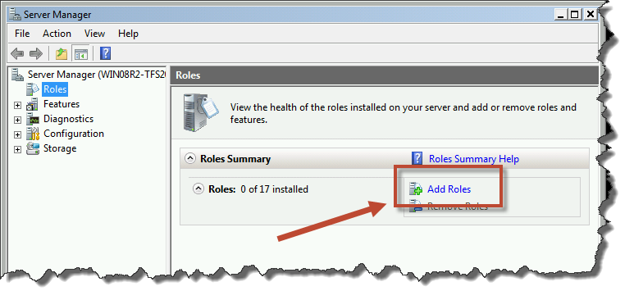
- Click Add Roles

You should now see the Add Roles Wizard.
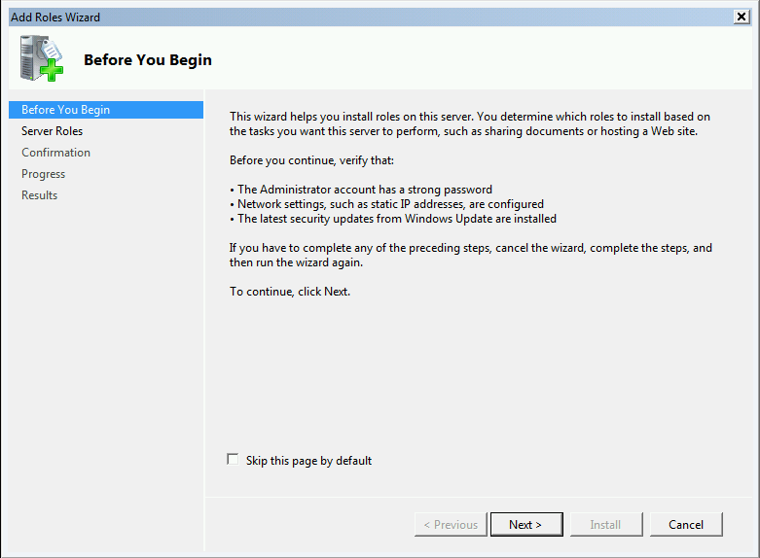
- Click Next

You should now see the Select Server Roles page.
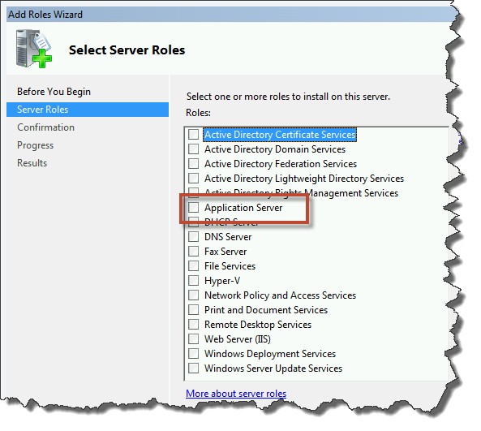
- Check Application Server

You should see a pop up dialog titled Add Roles Wizard like the image below.
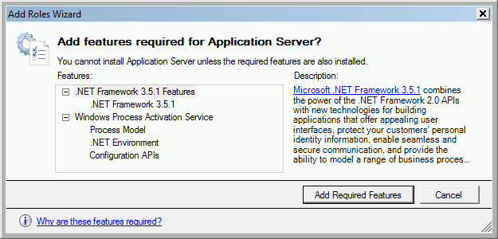
- Click the Add Required Features button
You should now be back on the roles selection page and Application Server should be checked.
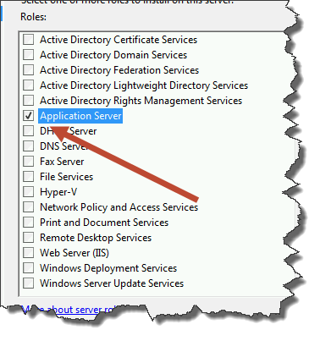
You now need to check the Web Server (IIS) role.
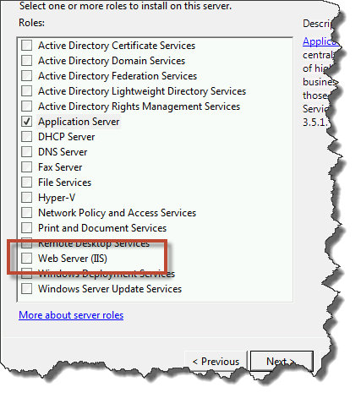
- Check the checkbox next to Web Server (IIS)
- Click the Next button

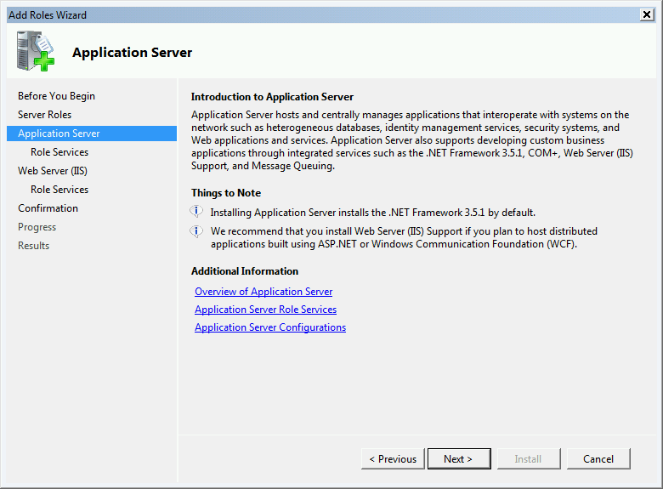
- Click Next

You should now be on the Select Role Services page.
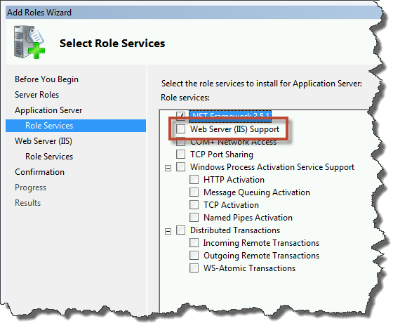
- Check the checkbox next to Web Server (IIS) Support

When you click Web Server (IIS) Support, you’ll get a new dialog like the image below.
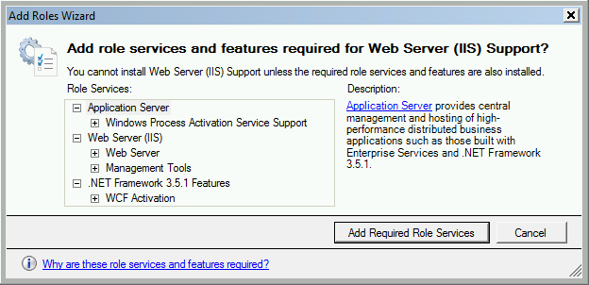
- Click the Add Required Role Services button

You should be back on the Select Role Services page.
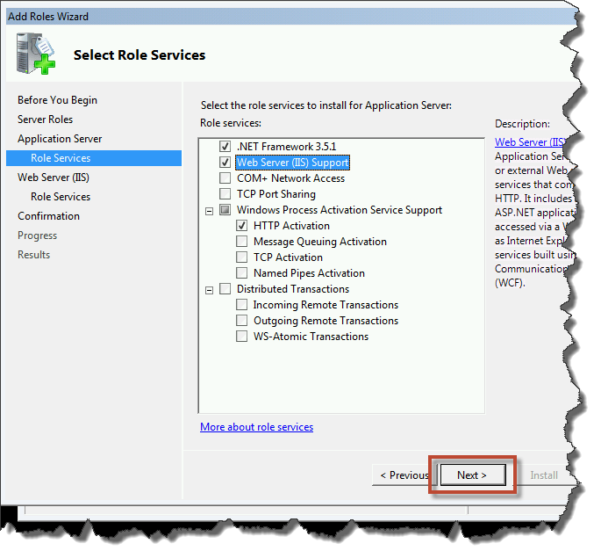
- Click Next

You should now see the Web Server (IIS) page.
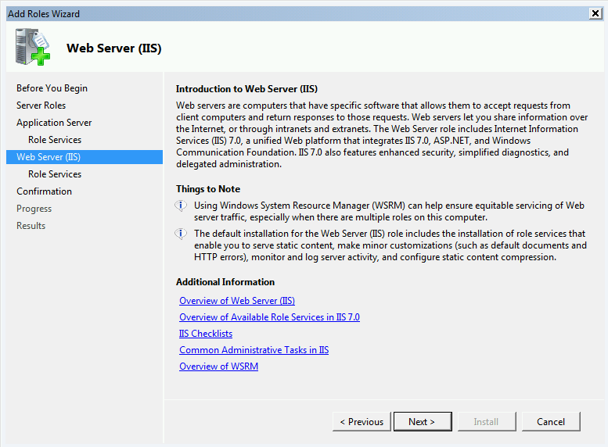
- Click Next

You should now be on the Select Role Services page.
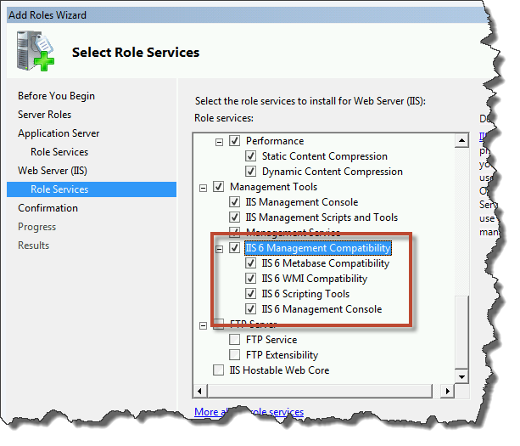
- In the list of roles, scroll down until you locate IIS 6 Management Compatibility
- Check IIS 6 Management Compatibility and all the child items as shown in the image above
- Click Next

You should now be on the Confirm Installation Selections page.
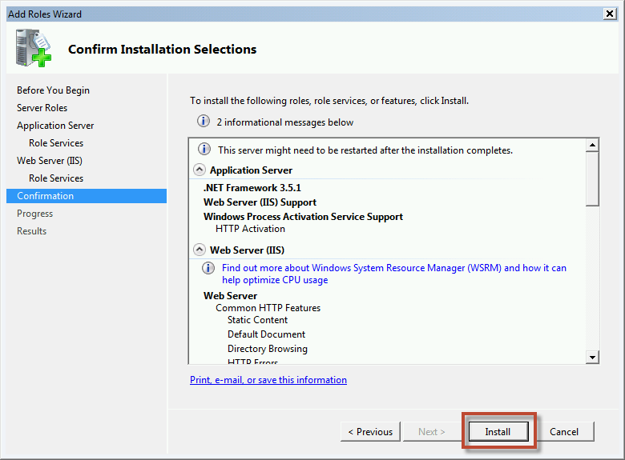
- Click the Install button

The installation should now be in progress.
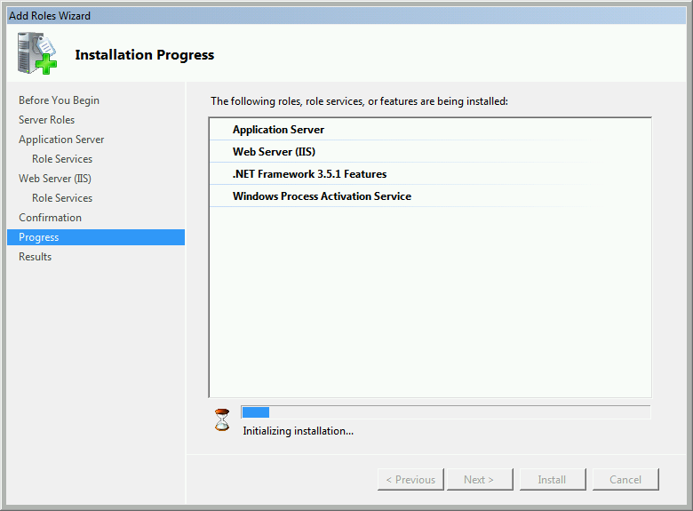

After the installation has completed, you should be on the Installation Results page. You should see Installation succeeded for the Application Server and Web Server (IIS) roles.
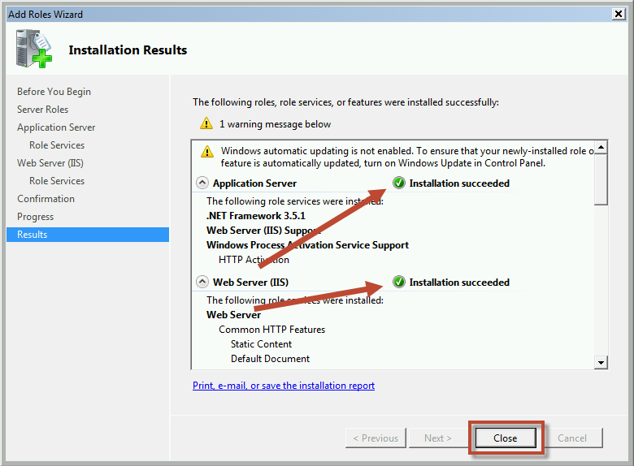
- Click Close

Pre-reqs are installed. Done.

Install SQL Server 2008 R2 for TFS2012

This chapter will walk you through the process of installing SQL Server 2008 R2 for TFS2012.
- Insert the SQL Server 2008 R2 disc or mount the appropriate ISO
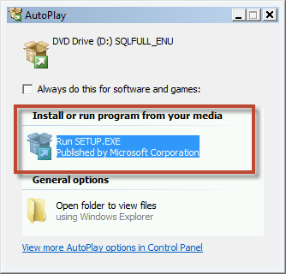
- Click Run SETUP.EXE

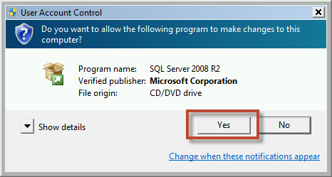
- Click Yes
You should now see the SQL Server Installation Center screen.
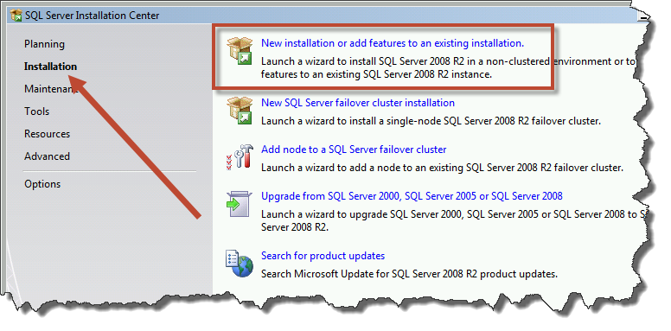
- In the left column, click Installation
- Click New installation or add features to an existing installation

On the Setup Support Rules page, you’ll see the result of the installer’s initial checks for possible installation blocking issues.
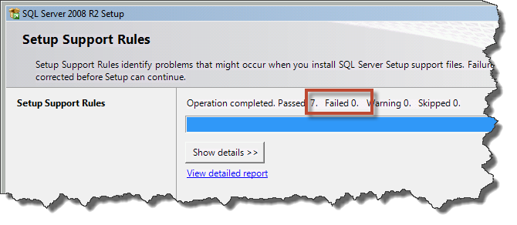
- Ensure that Failed says 0
- Click OK

You should now be on the Product Key page.
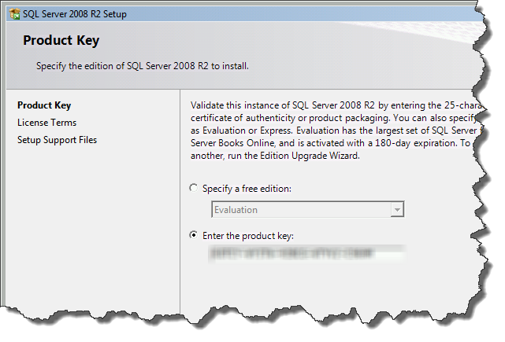
- Ensure that the correct product key is specified
- Click Next

You should now be on the License Terms page.
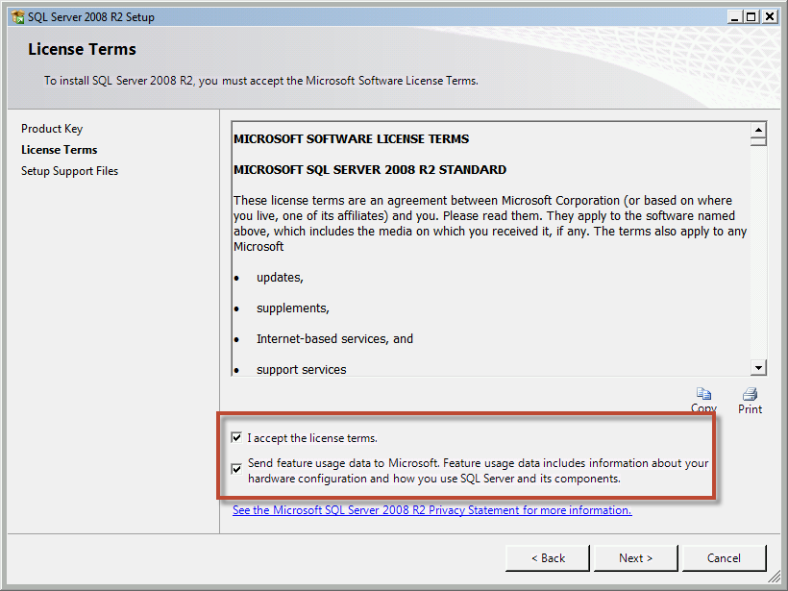
- Check I accept the license terms
- (Optional) Check Send feature usage…
- Click Next

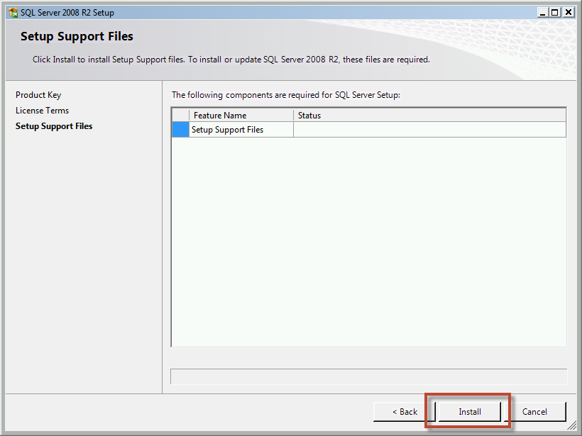
- Click Next

After the installation supporting files are installed, you’ll see another Setup Support Rules check page.
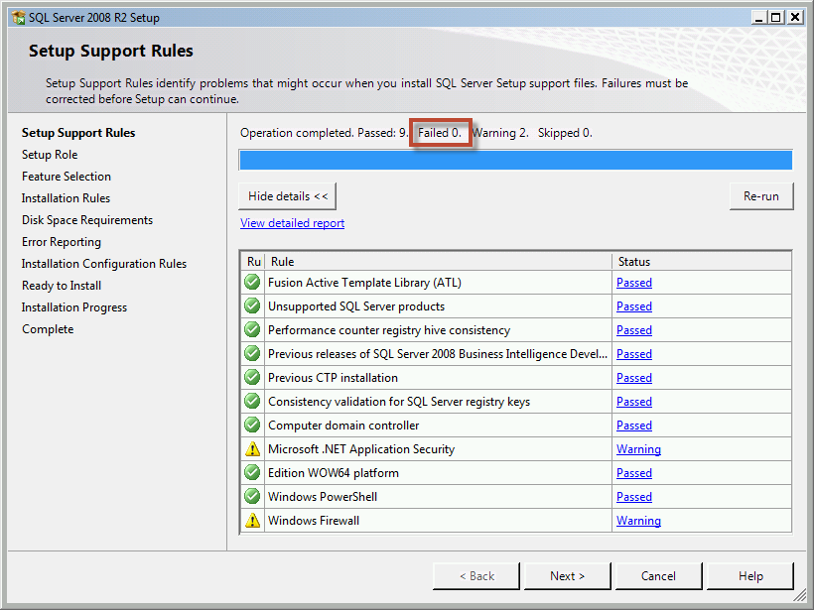
- Verify that Failed is 0
- Click Next

You should now be on the Setup Role page.
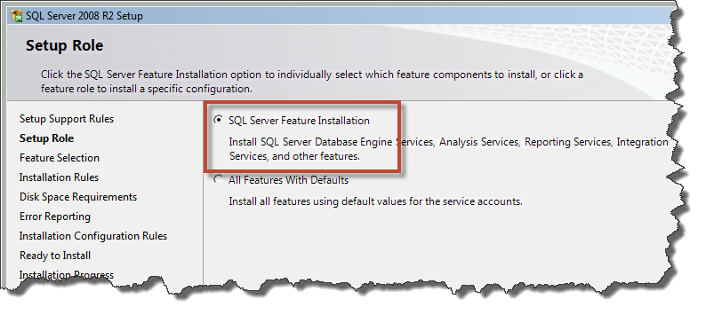
- Choose SQL Server Feature Installation
- Click Next

You should now be on the Feature Selection page.
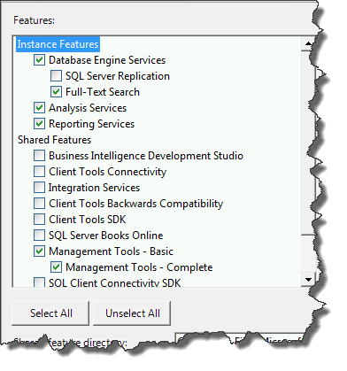
- Check the following items:
  - Database Engine Services
    - Full-Text Search
  - Analysis Services
  - Reporting Services
  - Management Tools – Basic
    - Management Tools – Complete
- Click Next

You should now be on the Instance Configuration page.
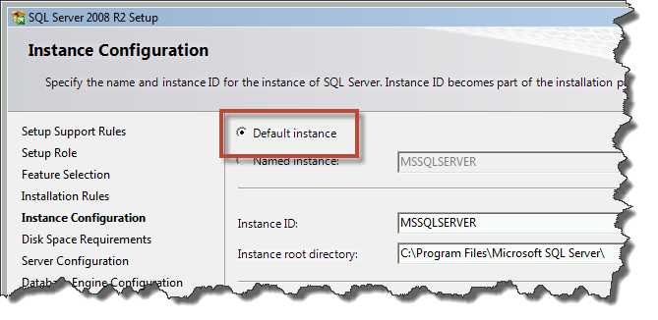
- Choose Default instance
- Click Next

You should be on the Disk Space Requirements page.
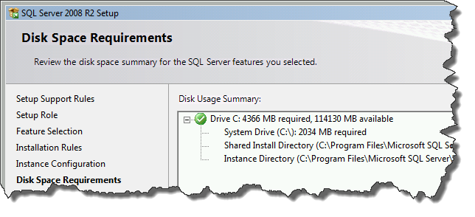
- Click Next
You should now be on the Server Configuration page.
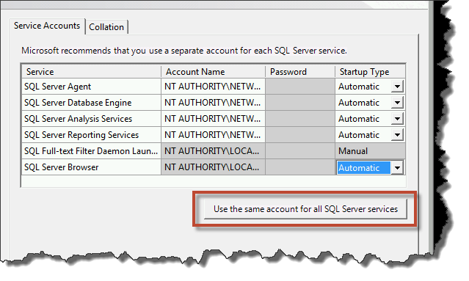
- Click Use the same account for all SQL Server services

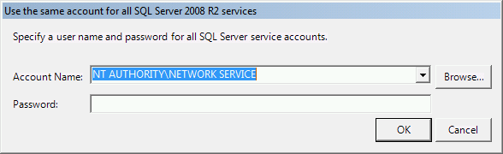
- From the Account Name drop-down list, choose NT AUTHORITY\NETWORK SERVICE
- Click OK

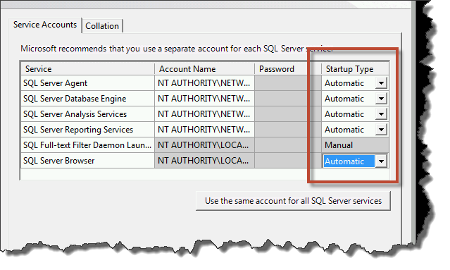
- Set the Startup Type column value to Automatic for all available services
- Click Next

You should now see the Database Engine Configuration page.
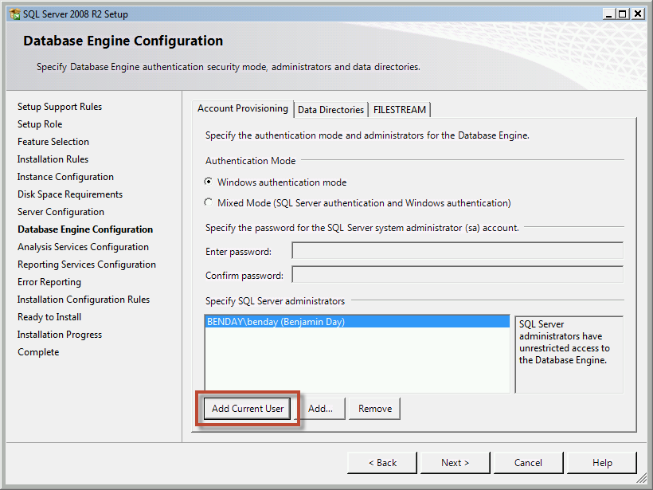
- Click Add Current User
- Click Next

You should now be on the Analysis Services Configuration page.
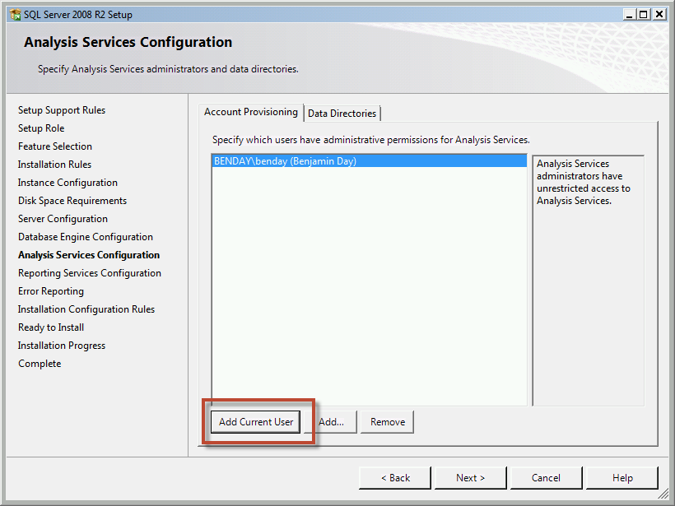
- Click Add Current User
- Click Next

You should now be on the Reporting Services Configuration page.
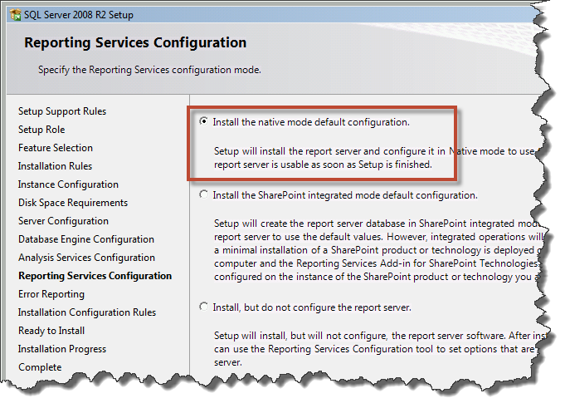
- Choose Install the native mode default configuration
- Click Next

You should now be on the Error Reporting page.
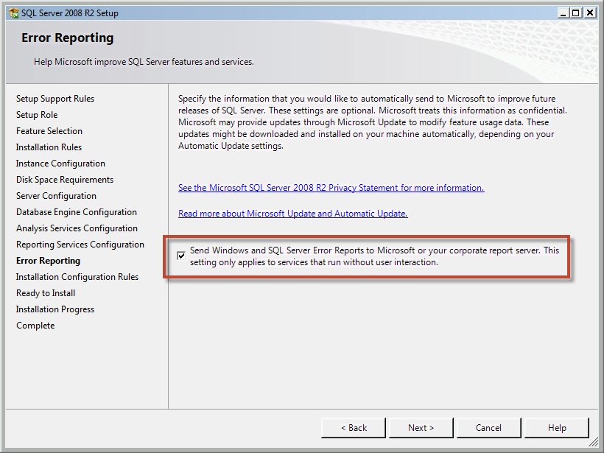
- (Optional) Check Send Windows and SQL Server Error Reports…
- Click Next

The installer will run another rules check on the Installation Configuration Rules page.
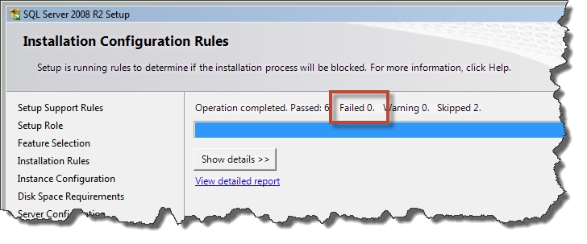
- Verify that Failed is 0
- Click Next

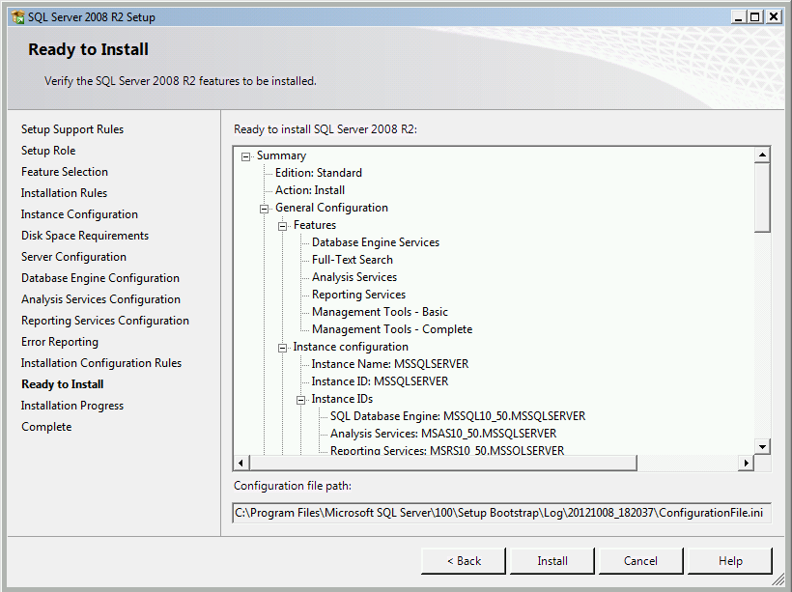
- Click Install

The installation should now be in progress.
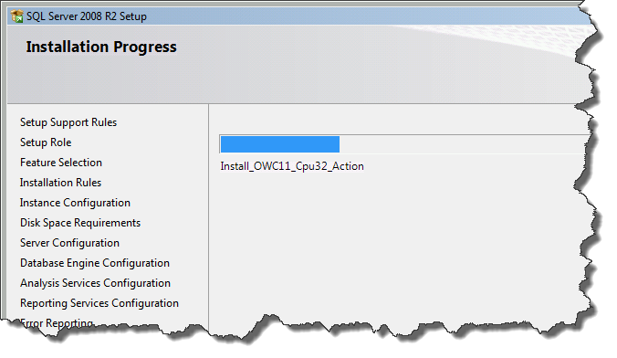

The installation should now be completed.
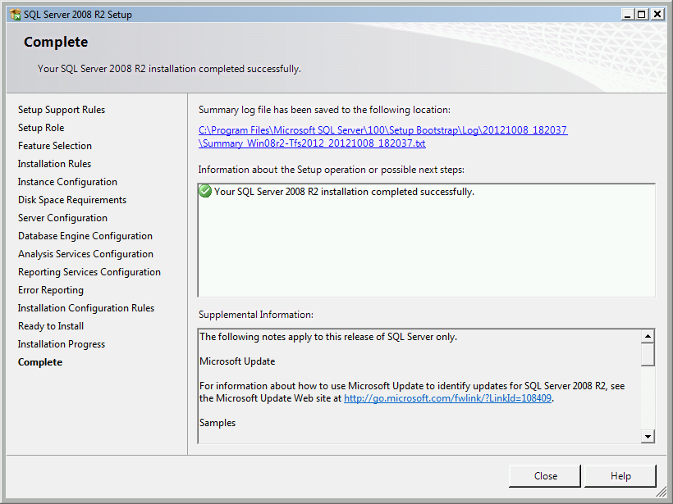
- Click Close

Now that SQL Server 2008 R2 is installed, you should install the latest service pack and any updates that are available from Windows Update.

Install Team Foundation Server 2012

This chapter will guide you through the process of installing Team Foundation Server 2012.
- Insert your TFS2012 disc or mount the appropriate ISO
- Open explorer.exe (aka. Windows Explorer)
- Navigate to your DVD drive
You should now be looking at an Explorer window that looks like the image below.
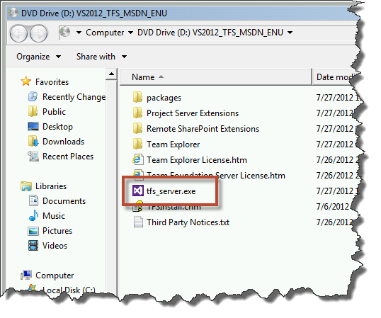
- Double-click tfs_server.exe

You should now see the Team Foundation Server Setup welcome screen.
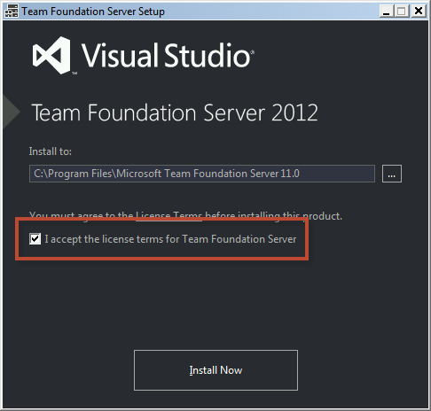
- Check I accept the license terms for Team Foundation Server
- Click Install Now

You will probably be prompted with a User Account Control dialog.
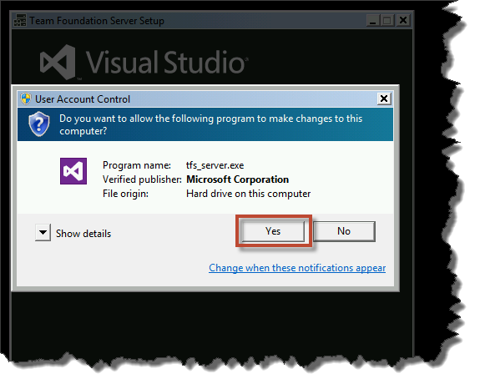
- Click Yes

The installer should now be running.
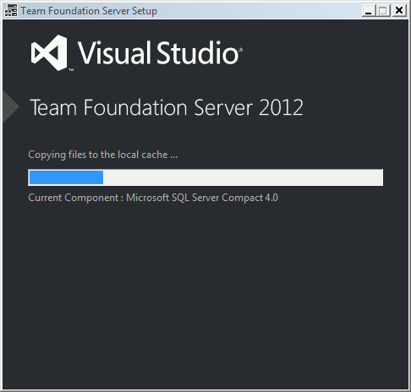

After the installer finishes, you’ll see the Team Foundation Server Configuration Center.
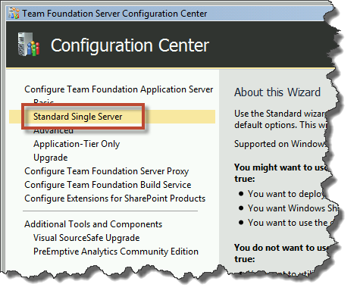
- Click Standard Single Server
- Click Start Wizard

You should now see the Standard Configuration Wizard.
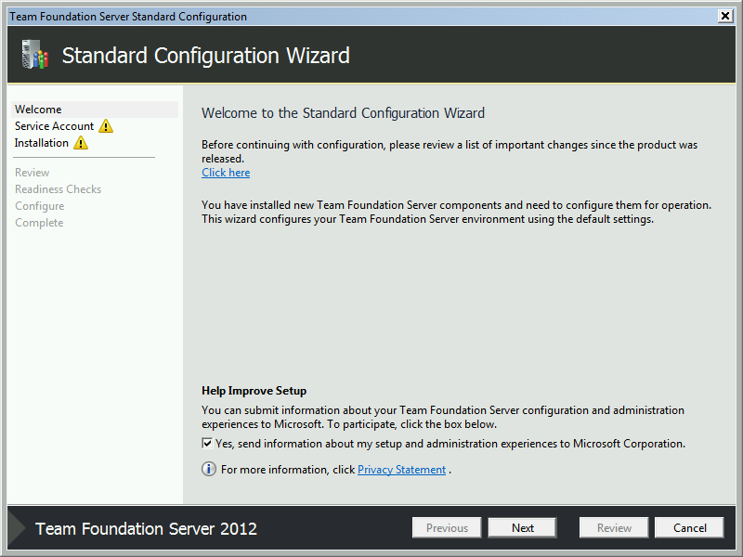
- Click Next

You should now be on the Service Account screen where you are prompted for a username and password for the integration from TFS to Reporting Services and SharePoint.
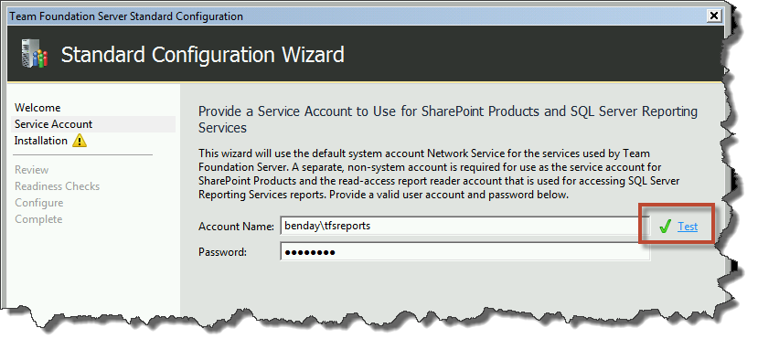
- In the Account Name box, enter the username you want to use. (You’ll probably want to use the TFSReports username.)
- In the Password box, enter the password for the user
- Click the Test button to verify the username and password
- Click Next

You should now see the Install SharePoint on this machine page of the installer. Unless you have 10GB of RAM on your server, you’re going to get a TF400080 warning in the validation results. In my opinion, you can safely ignore this if you don’t mind SharePoint being a little slow.
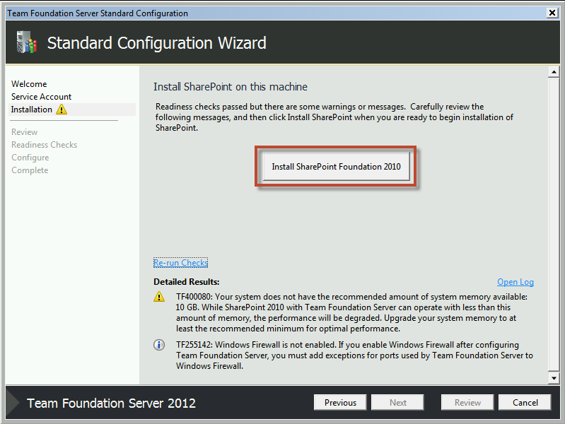
- Click Install SharePoint Foundation 2010

The installer for SharePoint should now be running.
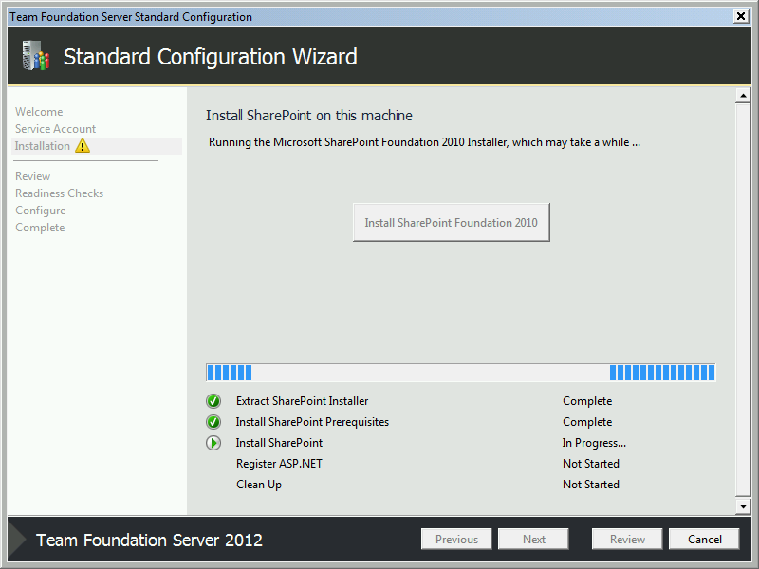

The installation of SharePoint should eventually complete.
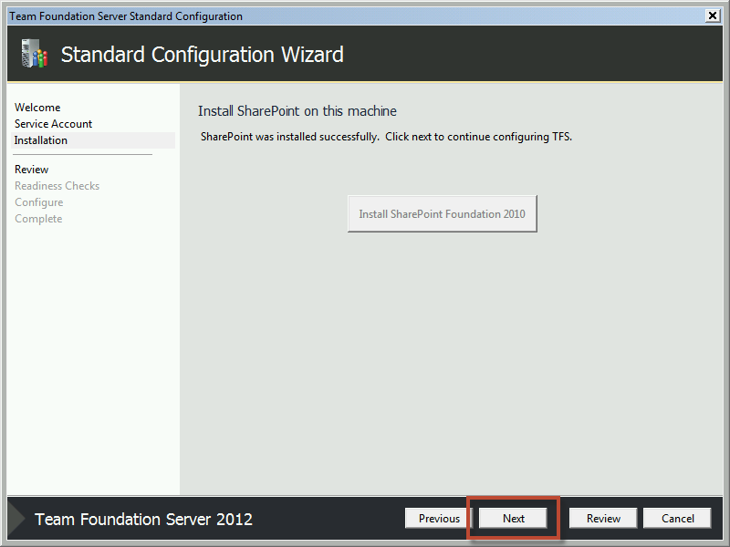
- Verify that the message says Sharepoing was installed successfully
- Click Next

You should now be on the Confirm the Configuration Settings Before Proceeding page.
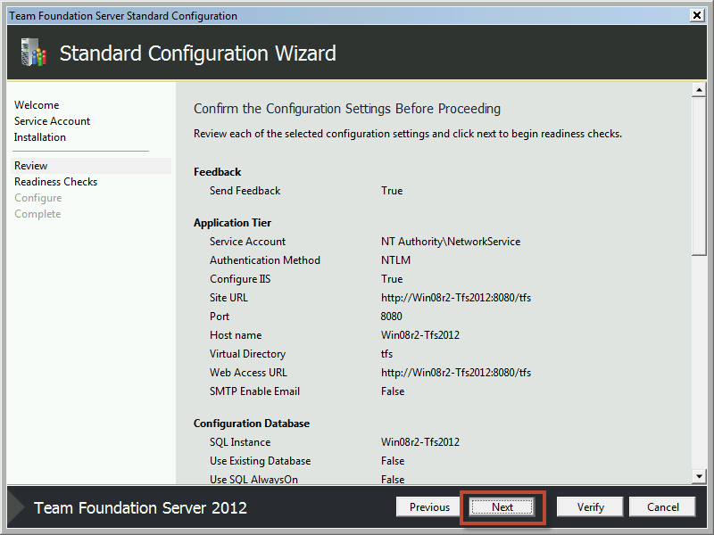
- Click Next

The installer will now run a series of checks on your system to verify whether the configuration is valid. Once again, you may receive the TF400080 warning about SharePoint 2010 and less than 10GB of memory. This can be safely ignored.
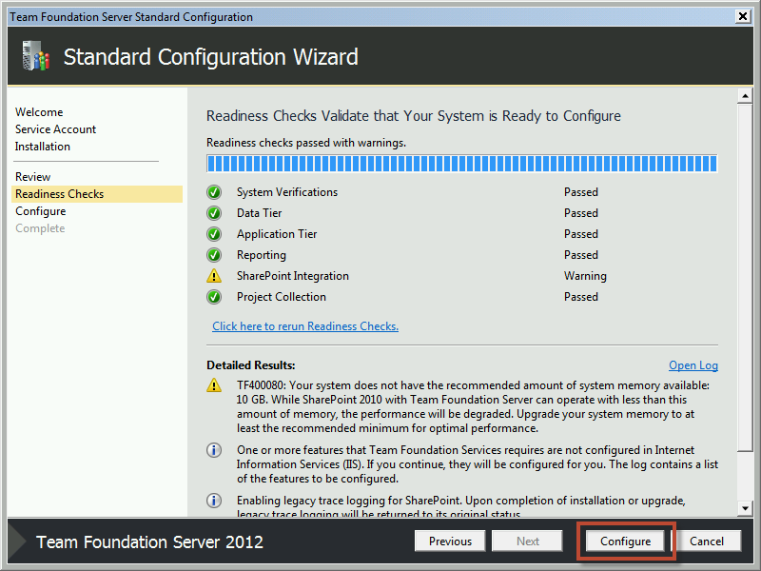
- Click the Configure button

The installer should now be configuring TFS.
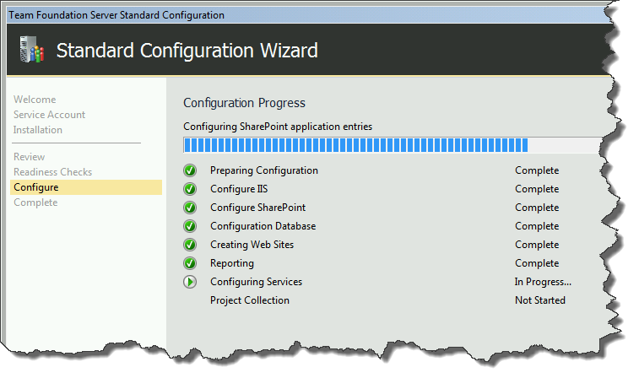

The configuration should complete with the message of Success.
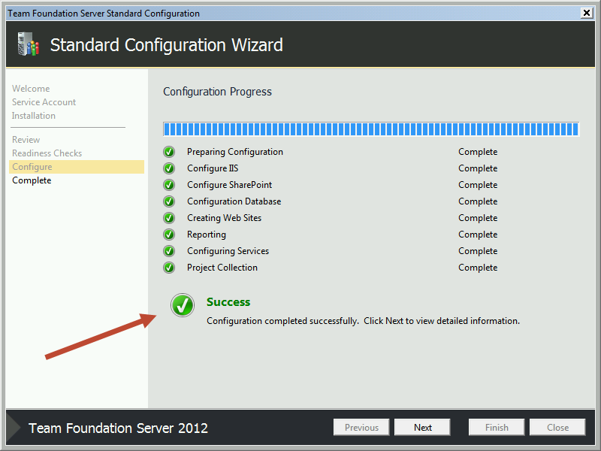
- Click Next

You should now be on a configuration summary page which should also report Success.
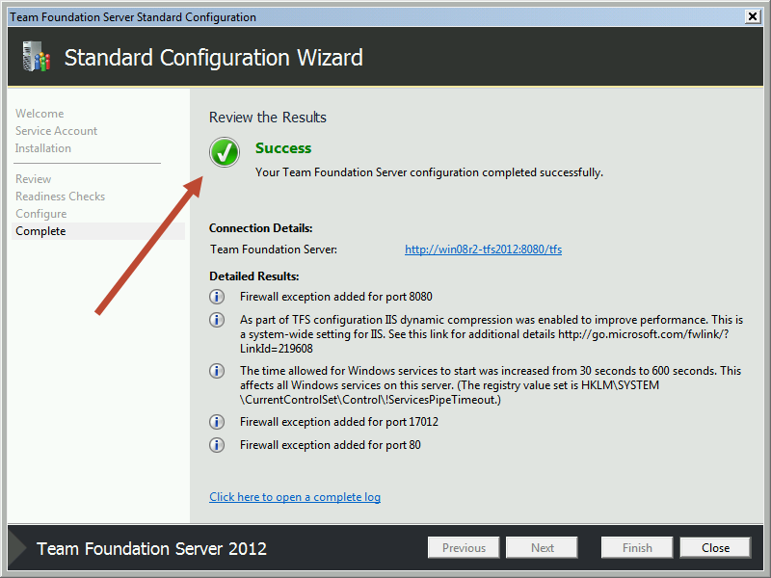
- Click Close

You should now be back at the main landing page of the Team Foundation Server Configuration Center.
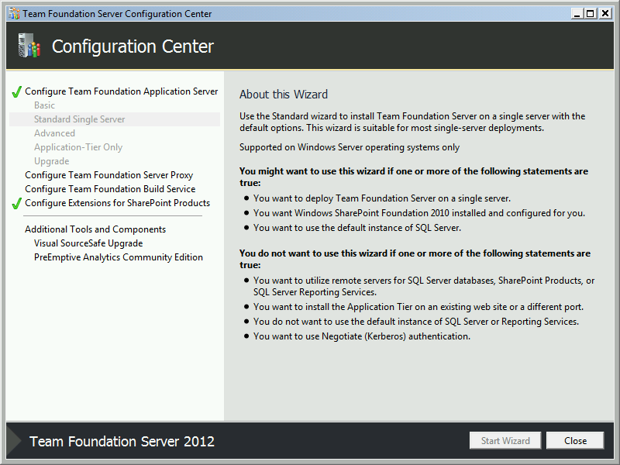
- Click Close

The Configuration Center window will close and the Team Foundation Server Administration Console will launch.
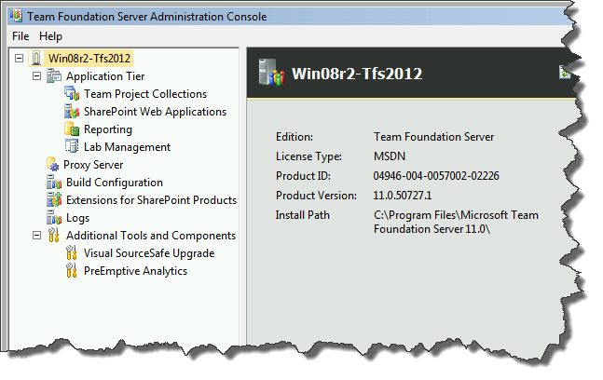
Team Foundation Server 2012 is now installed.

Update the TFS2012 Service Account

At the moment, TFS2012 is installed so that it runs under the username NT AUTHORITY\NETWORK SERVICE. This is fine if you are planning to use TFS2012 as is – without any build servers and without TFS Lab Management installed – but I find that permissions management can be a lot easier if you use a regular domain account.
In this lab, you’ll modify TFS2012 to use a different user for the service account. The user name you’ll use is TFSService but it can be any Active Directory domain user.

This work will all be done on the TFS machine.
- Log in to the TFS machine as an administrator
You’ll start by loading the Team Foundation Server Administration Console.
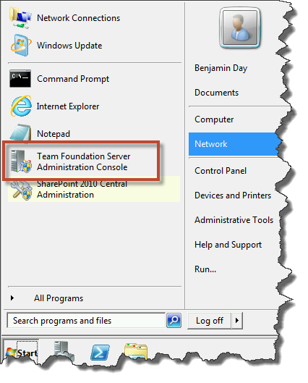
- Go to the Start menu
- Run Team Foundation Server Administration Console

You should now see the Team Foundation Server Administration Console.
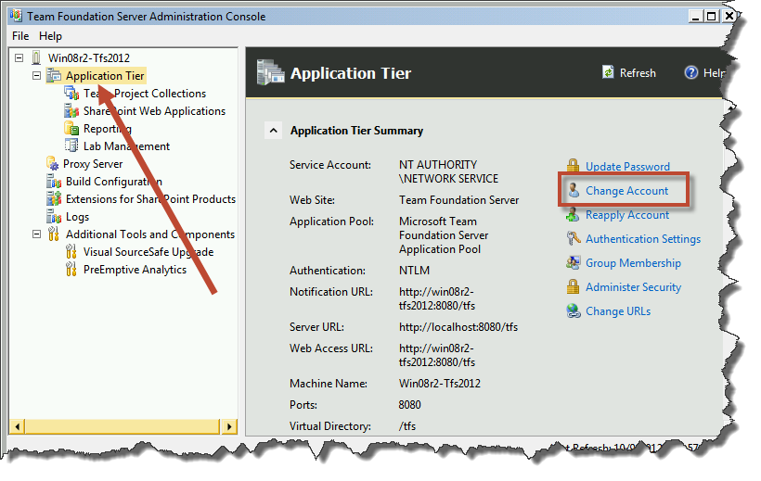
- In the left panel, click Application Tier
- In the right panel, click Change Account

You should now see a dialog titled Change Service Account.
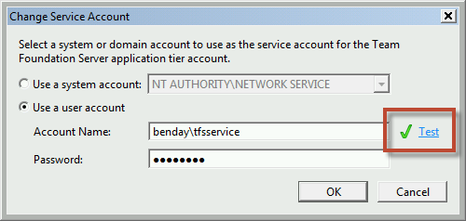
- Select Use a user account
- In the Account Name box, type the fully-qualified username (domain\username) you want to use
- In the Password box, type the password for the user account
- Click the Test button to verify the username and password
- Click the OK button

A new window should pop up named Change Service Account.
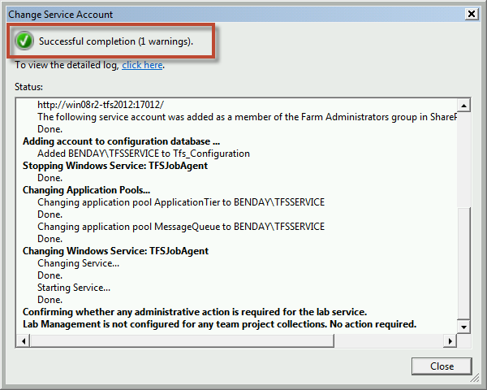
- After the operation is completed, verify that the operation was successful
- Click Close

The new service account should now be visible in the administration console window.
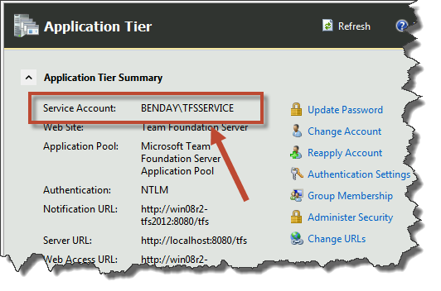
The service account for TFS2012 has now been changed.

Install the Team Foundation Server Build Service

In this module, you’ll install the Team Foundation Server 2012 Build Service.
- Mount the ISO for Team Foundation Server 2012
- After mounting, open Explorer.exe
- Navigate to the root folder of the TFS installer
You should see directory that looks something like the screenshot below. From here you’ll run the installer for TFS, tfs_server.exe.
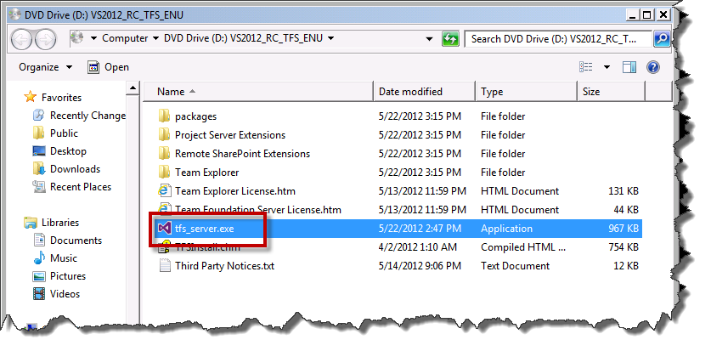
- Double-click tfs_server.exe

You should now see the first screen of the TFS installer.
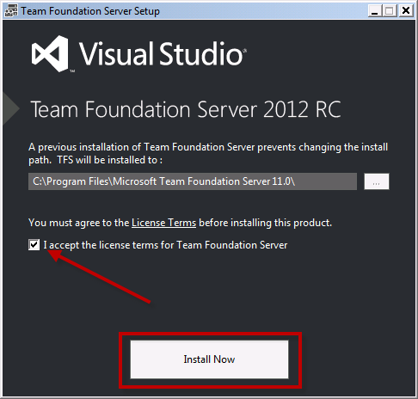
- Check the I accept the license terms for Team Foundation Server
- Click Install Now

You should now be on the Configuration Center.
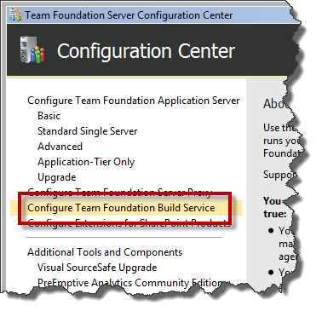
- Choose Configure Team Foundation Build Service from the left column
- Click the Start Wizard button

You should now see the Build Service Configuration Wizard page.
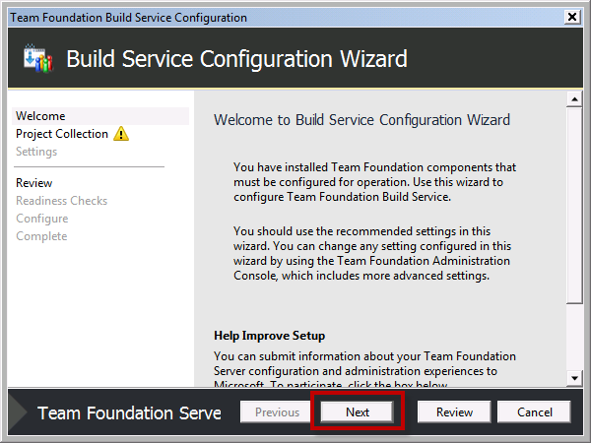
- Click Next

You should see the Select a Team Project Collection page.
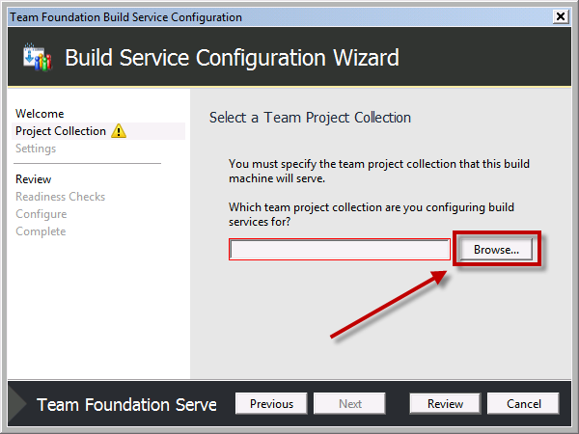
- Click the Browse button to begin the process of picking a TPC for this build server

You should now see the Connect to Team Project Collection dialog.
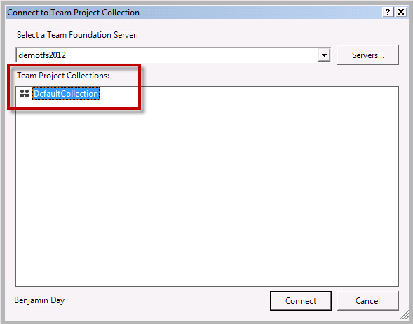
- Choose your desired TFS machine from the Select a Team Foundation Server drop down list. (NOTE: if your server isn’t in the list, click Servers… and follow the wizard steps to connect to your TFS machine.)
- After choosing your TFS, select your Team Project Collection
- Click Connect

You should now be back at the Select a Team Project Collection page.
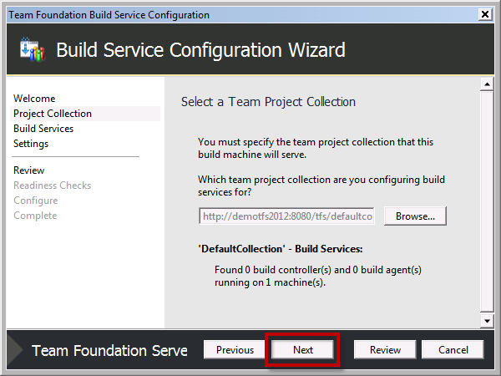
- Click Next

You should now see the Build Service page.
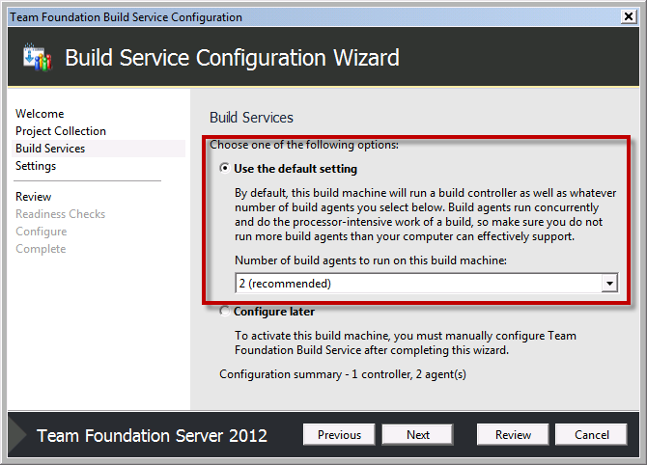
- Select Use the default setting
- From the Number of build agents to run on this build machine drop down list, choose the “recommended” value
- Click Next

You should now be on the Configure build machine page.
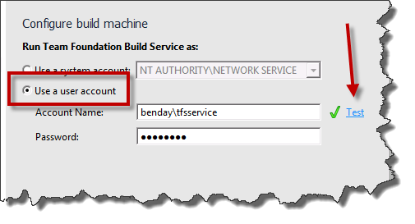
- Choose Use a user account radio button
- Enter the TFS Service account name in the Account Name textbox
- Enter the TFS Service account password in the Password textbox
- Click the Test link to verify the username and password
- Click Next

You should now see the Confirm the Configuration Settings Before Proceeding page.
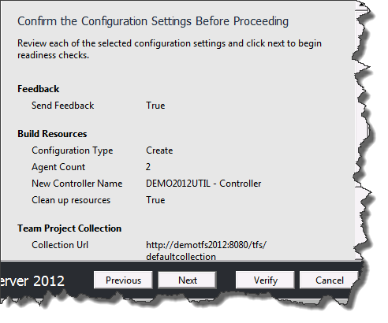
- Click Next

The installer will run some verifications to see that the build service can be configured.
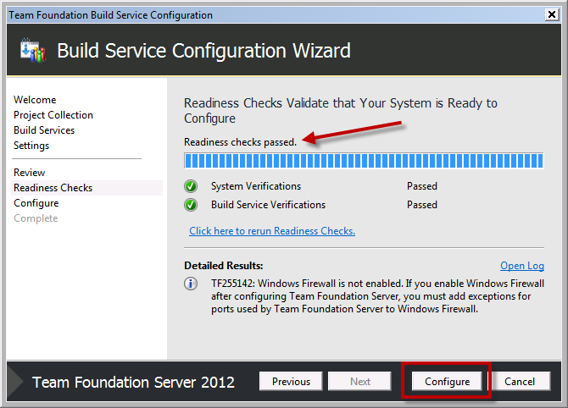
- Verify that the readiness check have passed
- Click the Configure button

You should now see the Configuration Progress dialog.
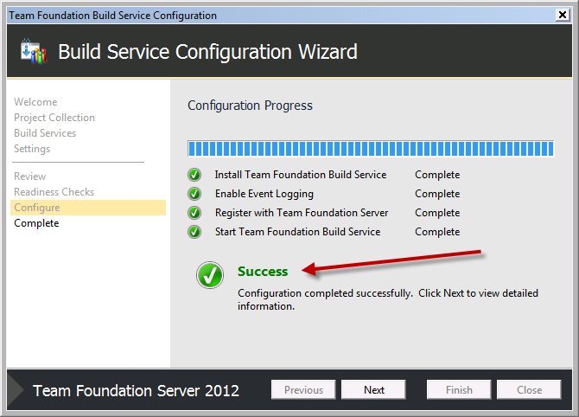
- Verify that the result is Success
- Click Next

You should now see the Review the Results page.
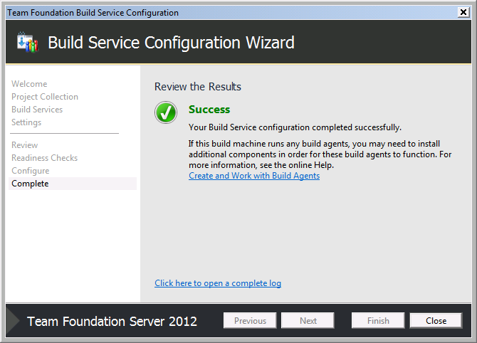
- Click Close

You should now be back at the main page of the Configuration Center. You should see that there is a check mark next to Configure Team Foundation Build Service indicating that this feature has been installed.
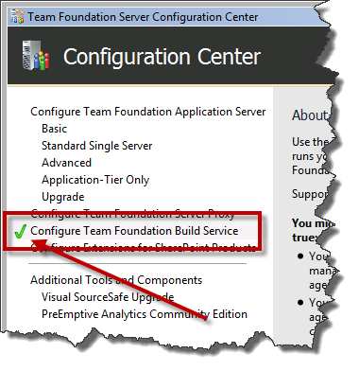
- Click Close to exit the installer
The TFS Build service is now installed.

Install the pre-requisites for System Center Virtual Machine Manager 2012
This document will walk you through the process of installing the pre-requisites for System Center Virtual Machine Manager 2012 (SCVMM). For the purposes of this document, we’ll assume that you’ve already installed the operating system and that all “important” and “recommended” Windows Update patches have already been installed.
SCVMM2012 has the following pre-requisites:
- Windows Server 2008 R2 x64 with Service Pack 1
  - Standard, Enterprise, or Datacenter
  - NOTE: the server name cannot contain the string “-SCVMM-“
- WinRM 2.0
- .NET 3.5 Service Pack 1
- Windows Automated Installation Kit for Windows 7
  - http://www.microsoft.com/en-us/download/details.aspx?id=5753
- SQL Server x64
  - SQL Server 2008 R2 x64
    - Standard, Datacenter, or Enterprise
  - SQL Server 2008 x64
    - Standard or Enterprise
To perform the step described in this document, you should be logged on as an Administrator.

Install SQL Server 2008 R2 x64
This section will walk you through the process of installing SQL Server 2008 R2 x64. The installation process is similar for other versions of SQL Server but not 100% equal.
- Insert the DVD or mount the ISO for a supported version of SQL Server
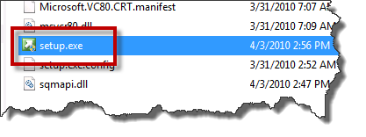
- Run setup.exe

If the .NET Framework has not already been installed on this server, you will be prompted to install it.
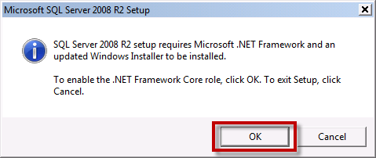
- If prompted, click OK

You will eventually see the SQL Server Installation Center.
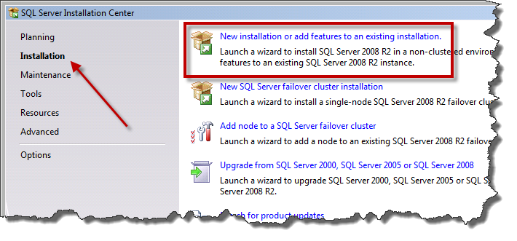
- In the left panel, click Installation
- Click New installation or add features to an existing installation
The installer will now run a series of pre-requisite checks for SQL Server and will put you on the Setup Support Rules dialog.
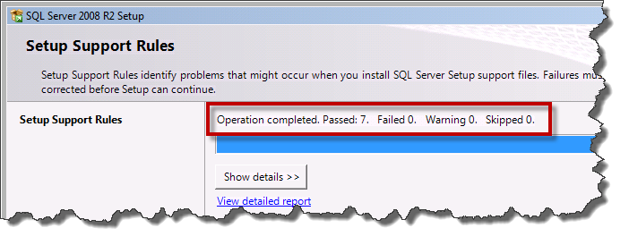
- Verify that the count is zero for Failed, Warning, and Skipped.
- If there are any failures, fix the failures before continuing.
- If everything passes, click OK

You should now see the Product Key page.
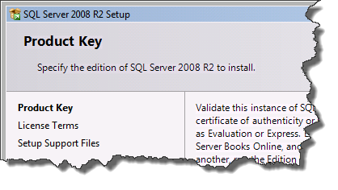
- Verify that there is a product key
- Click Next
The License Terms page should now be visible.
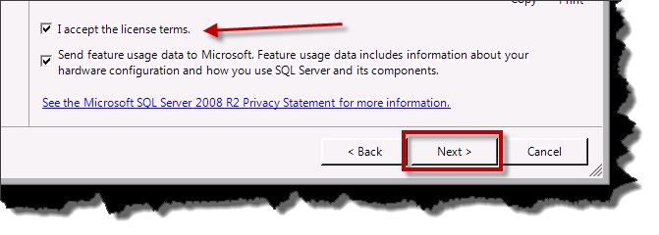
- Check I accept the license terms
- (Optional) Check Send feature usage data…
- Click Next

The Setup Support Files dialog should now be visible.
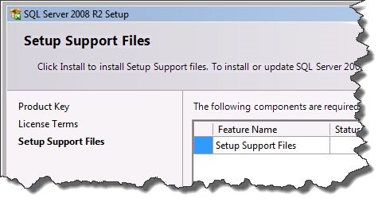
- Click Install
After the support file installation step has completed, you should be on the Setup Support Rules page.
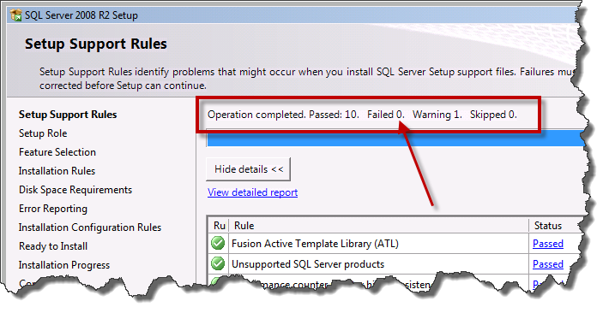
- Verify that there are zero Failed operations.
- Click Next

The Setup Role page should be visible.
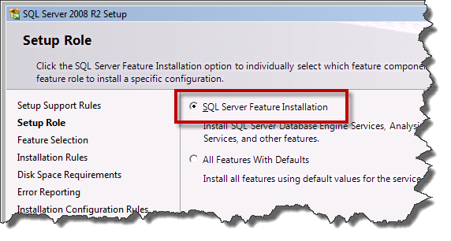
- Choose SQL Server Feature Installation
- Click Next

You should now see the Feature Selection screen. The only feature that is required by SCVMM is Database Engine Service. If you want to keep the disk usage for your installation of SQL Server to a minimum, only choose this feature. It is sometimes helpful to have the SQL Server Management Tools installed on this server in case you need to run queries or perform miscellaneous maintenance operations but, if you have these tools installed on a different machine, you can safely skip this feature.
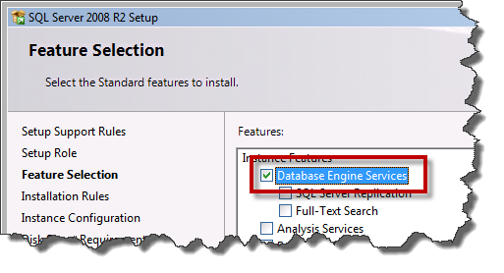
- Check Database Engine Services
- (Optional) Check Management Tools – Basic
- (Optional) Check Management Tools – Complete
- Click Next

Before the installer actually installs your features, it will do one last check. You should now see the Installation Rules page.
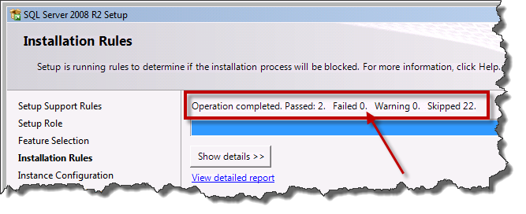
- Verify that there are zero Failed operations.
- Click Next
You should see the Instance Configuration page.
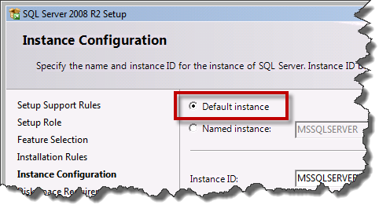
- Choose Default instance
- Click Next

The Disk Space Requirements screen should be visible and the disk space usage check should be passing.
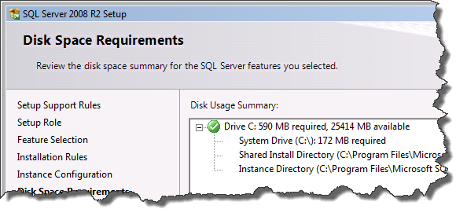
- Click Next
The Server Configuration screen should be visible and you’ll need to make several adjustments to the default values.
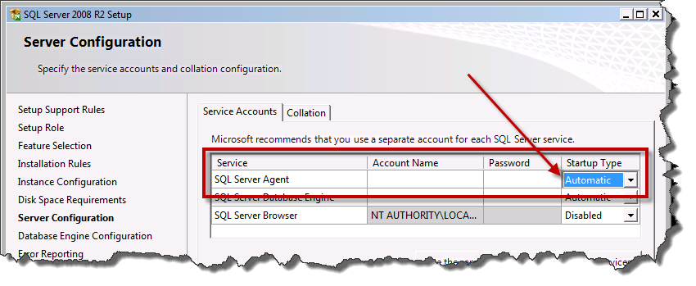
- Locate the row for SQL Server Agent and set the Startup Type value to Automatic

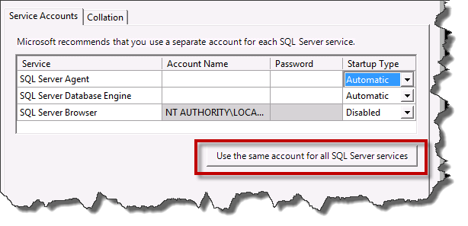
- Click Use the same account for all SQL Server services
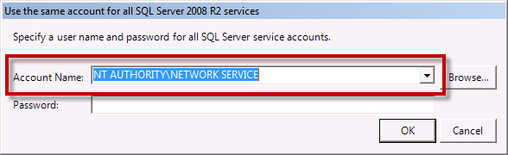
- From the Account Name drop-down list, choose NT AUTHORITY\NETWORK SERVICE
- Click OK

The Server Configuration screen should now look like the following image.
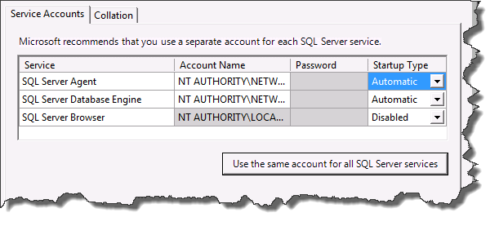
- Click Next

The Database Engine Configuration page should now be prompting you for information about Account Provisioning. SQL Server does not automatically add members of the Windows Administrators group as SQL Server administrators. My recommendation is to add the Domain Admins group as SQL Server administrators but this is optional.
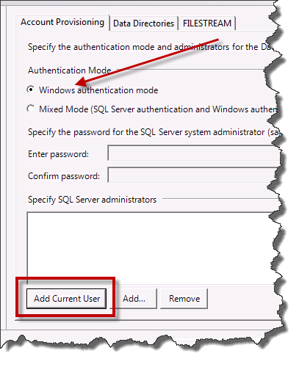
- Verify that Windows authentication mode is selected
- Click Add Current User to mark the current user account as an administrator in SQL Server

(Optional) If you want to add the members of the Domain Admins group as SQL Server administrators, follow these steps.
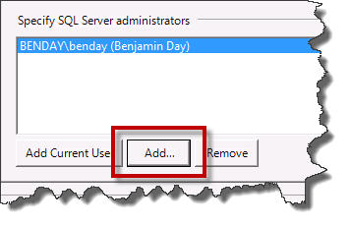
- Click Add
You should see the Select Users, Computers, or Groups dialog.
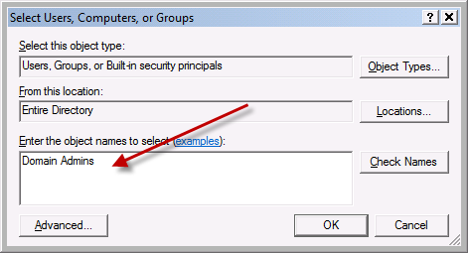
- In the Enter the object names to select box, type Domain Admins
- Click OK

The Specify SQL Server administrator list should now look something like this.
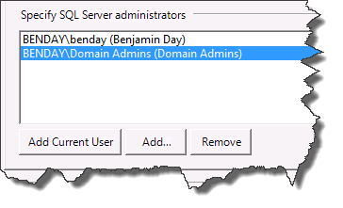
- Click Next
You should now be on the Error Reporting page.
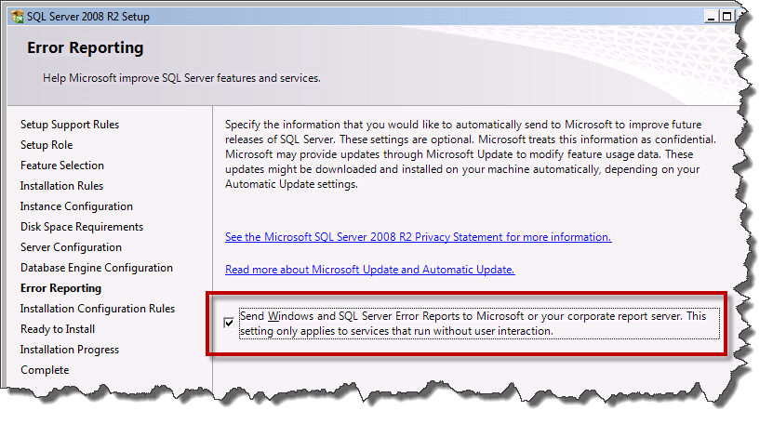
- Check the Send Windows and SQL Server Error Reports to Microsoft checkbox
- Click Next

Another Installation Configuration Rules check.
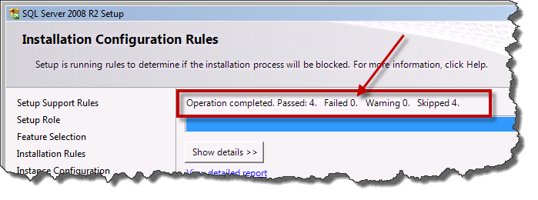
- Verify that there are zero Failed operations
- Click Next

You should now see the installation summary on the Ready to Install screen.
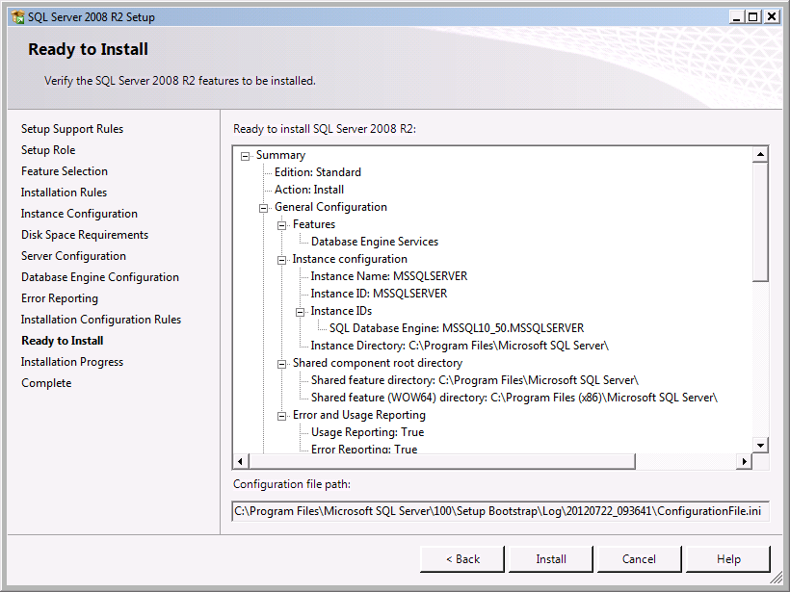
- Click Install

The installer should run and you should eventually see the Complete screen.
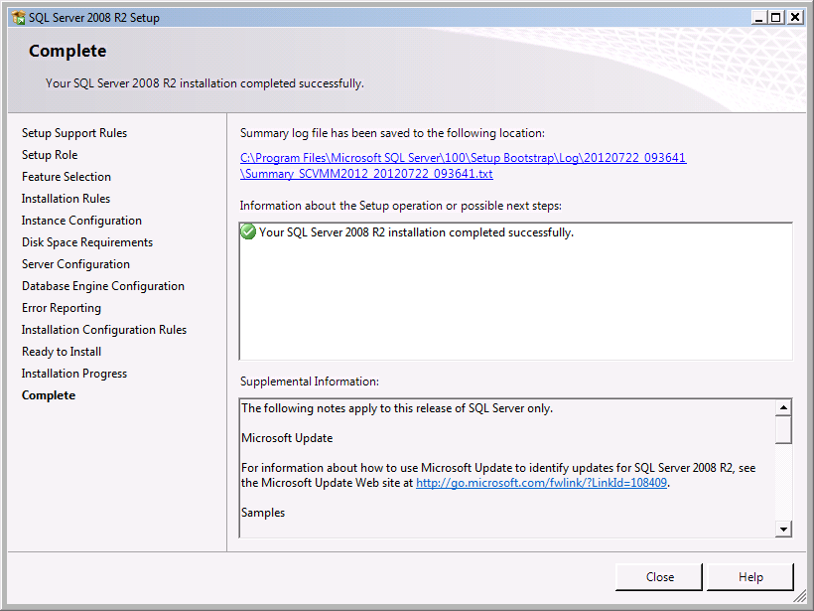
- Click Close

Install SQL Server 2008 Service Pack
Now that SQL Server 2008 R2 has been installed, you should download and install the latest service pack.
- Download and install the latest service pack for SQL Server 2008 R2

Install the Windows Automated Installation Kit for Windows 7

- Mount the ISO image for WAIK, KB3AIK_EN.iso
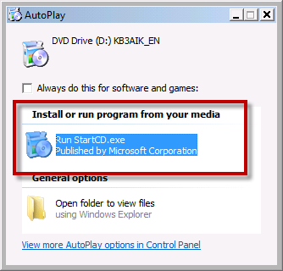
- Click Run StartCD.exe

The installer welcome window should be visible.
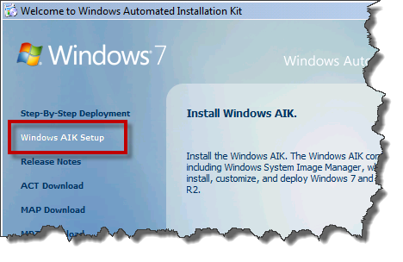
- From the left column, click Windows AIK Setup

The installer should load and you should see the Welcome to the Windows Automated Installation Kit Setup Wizard page.
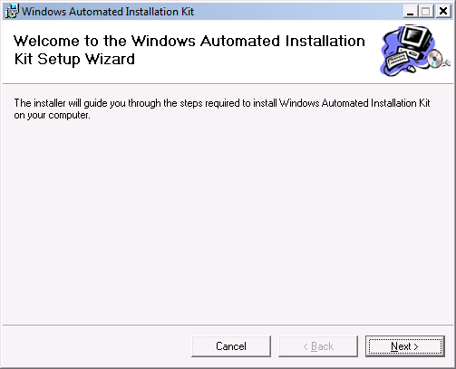
- Click Next

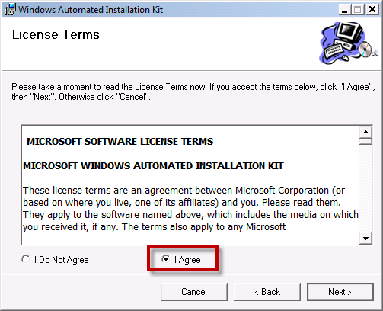
- Choose I Agree
- Click Next

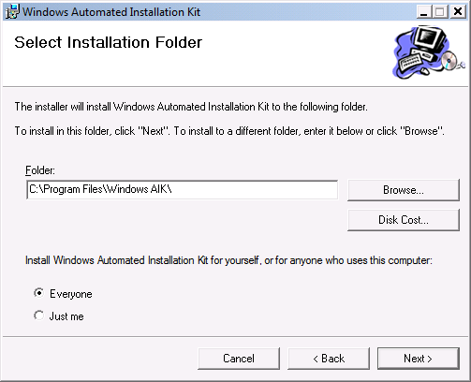
- Choose Everyone
- Click Next

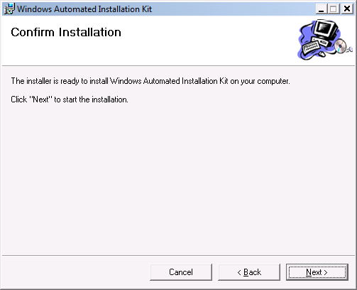
- Click Next

You should now be on the Installation Complete dialog for the Windows Automation Installation Kit.
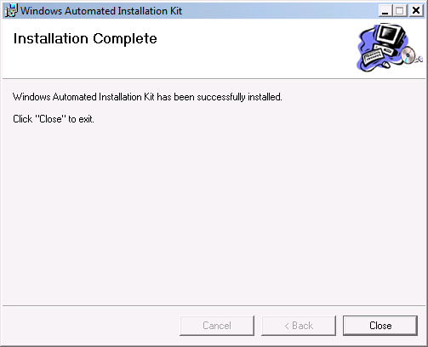
- Click Close
The pre-requisites for System Center Virtual Machine Manager 2012 are now installed.

Install System Center Virtual Machine Manager 2012

In this section, you’ll install SCVMM 2012.
- Insert the SCVMM 2012 disk or mount the ISO
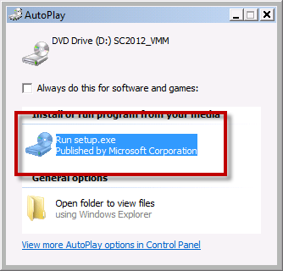
- Click Run setup.exe

You should see the Microsoft System Center 2012 Virtual Machine Manager installer welcome page.
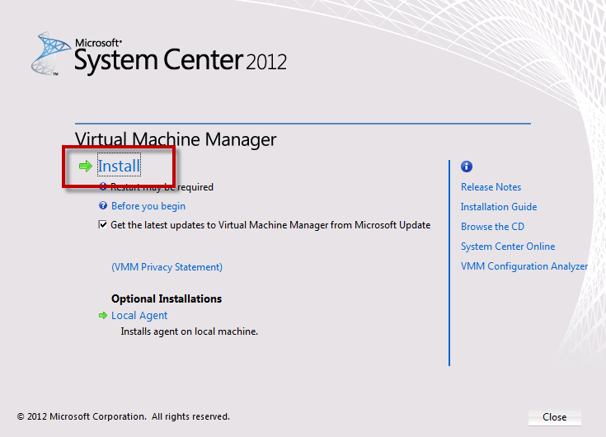
- Click Install

The setup wizard will prompt you to select features to install.
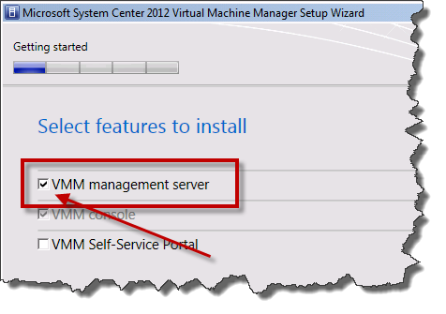
- Check VMM management server
- Click Next

You should now see the product registration information screen.
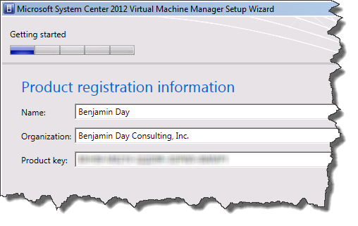
- Fill out the Name and Organization box with the relevant values for your company
- Enter a Product key
- Click Next

You should now be on the Please read this license agreement page.
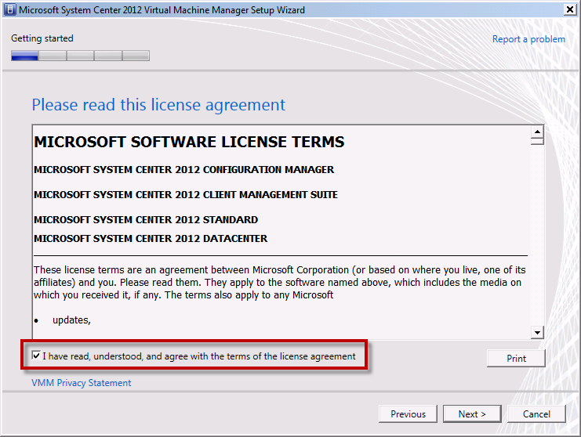
- Read the license terms
- Check I have read, understood, and agree with the terms of the license agreement
- Click Next

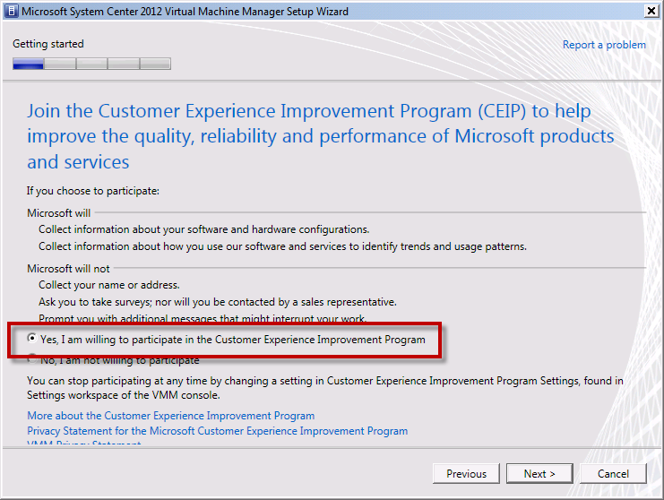
- Choose whether you want to participate in the Customer Experience Improvement Program
- Click Next

You should now be on the Microsoft Update page.
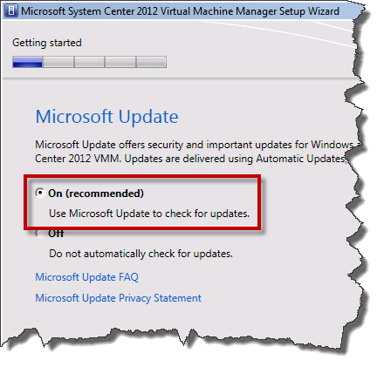
- Choose On (recommended)
- Click Next

On the Installation location page, you have the opportunity to choose where SCVMM is installed on disk. It is recommended to accept the defaults.
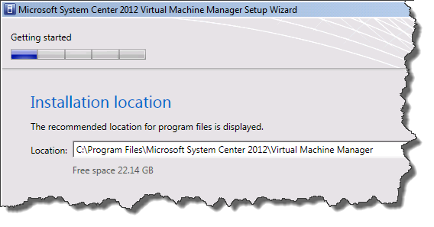
- Modify the Location only if absolutely necessary
- Click Next

You should now see the Database configuration page.
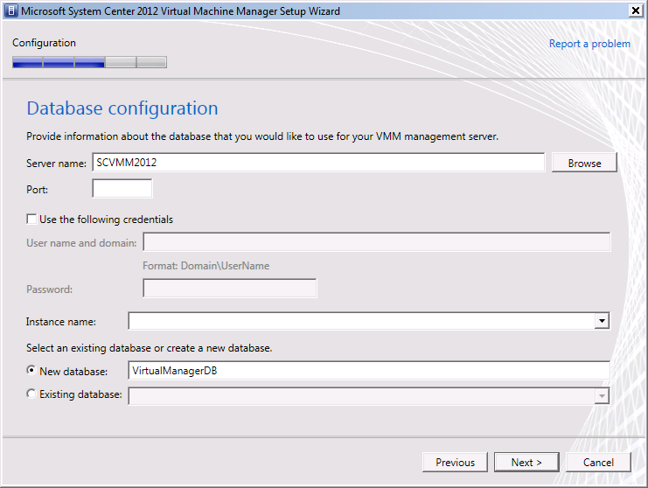
- Click Next

You should now see the Configure service account and distributed key management page.
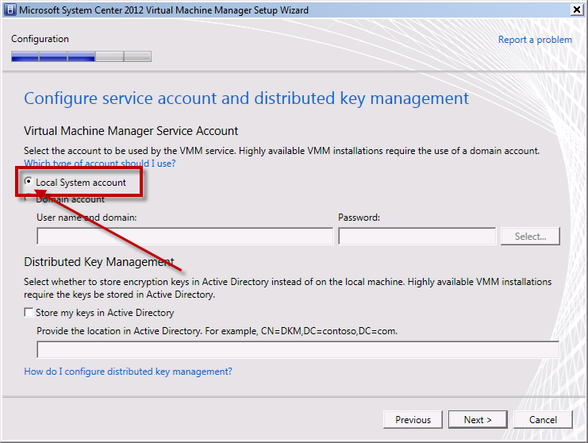
- Choose Local System account
- Uncheck Store my keys in Active Directory
- Click Next

You should now see the Port configuration screen.
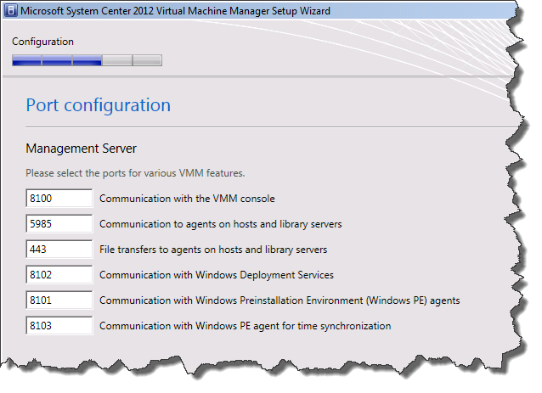
- Click Next

You should see the Library configuration screen.
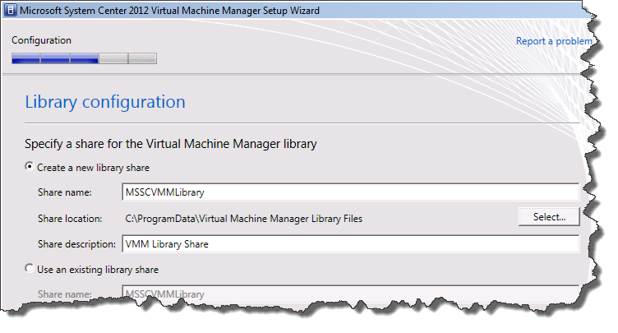
- Click Next

The wizard should now be on the Installation summary page.
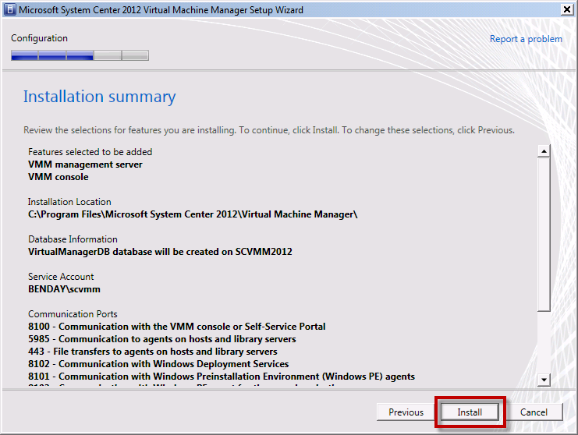
- Click Install to begin the installation

The installer process should run and eventually display the Setup completed successfully message.
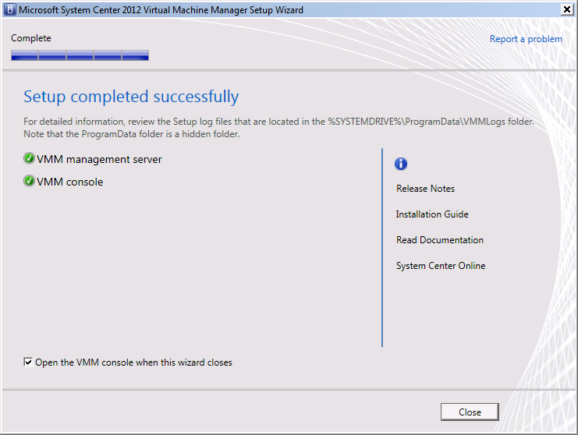
- Check Open the VMM console when this wizard closes
- Click Close to exit the installer and start the VMM console

Verify You Can Connect
The installer should exit and you should see a new dialog prompting you to Connect to Server.
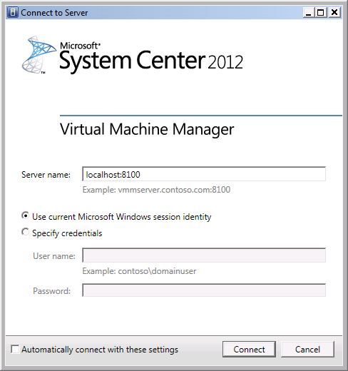
- Click Connect

If you see the following screen, then you’ve managed to connect to your new SCVMM server.
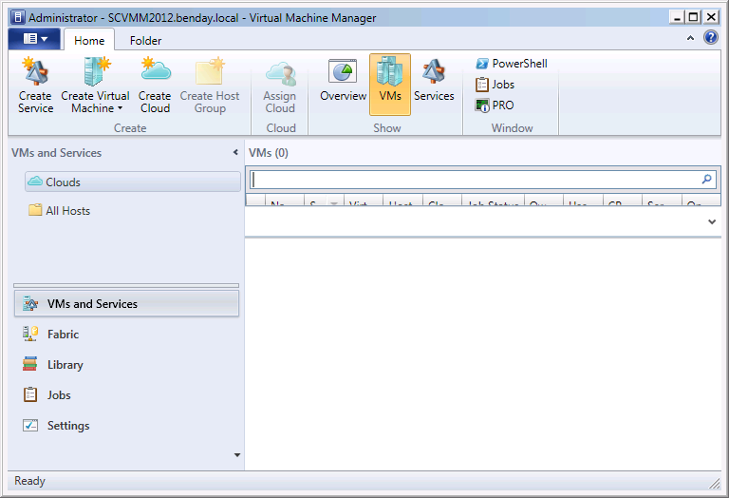

The next step is to add the Hyper-V host that you’ll eventually use for Team Foundation Server 2012 Lab Management.

Add a Hyper-V Host Machine to SCVMM 2012

You should still be on the main page of the SCVMM admin console and you should see the VMs and Services section of the user interface. In the left column, you should see VMs and Services and under that you should see a node that is labeled All Hosts.
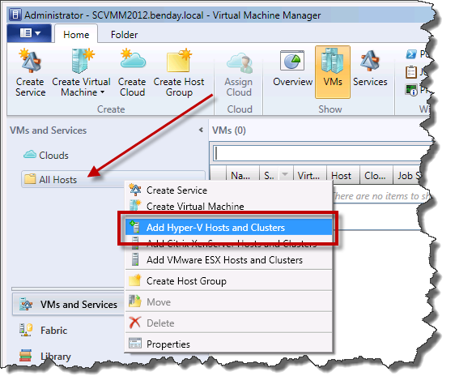
- Right-click All Hosts and choose Add Hyper-V Hosts and Clusters

The Add Resource Wizard should launch and you should see the Resource location page.
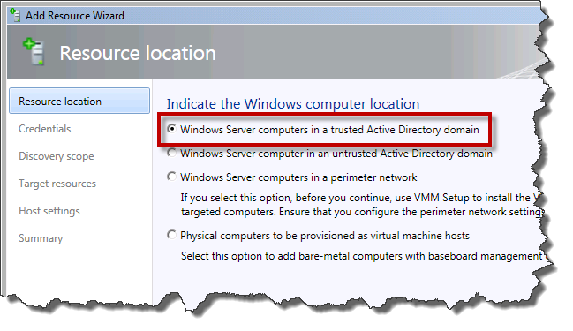
- Choose Windows Server computers in a trusted Active Directory domain
- Click Next

You should now see the Specify the credentials to use for discovery page. This page requires you to enter the credentials for a user who is an administrator on the target Hyper-V host machine. These credentials are only going to be used for installing the SCVMM Agent Service and will not be used for running the service.
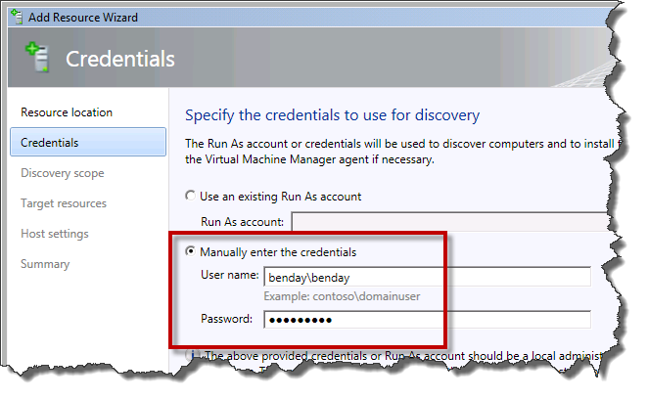
- Choose Manually enter the credentials
- In the User name field, enter the user name for the installation user
- In the Password field, enter the password for the installation user
- Click Next

You should now see the Specify the search scope for the virtual machine host candidates screen. This screen allows you to enter the name of the server or servers that you want to configure as a Hyper-V host.
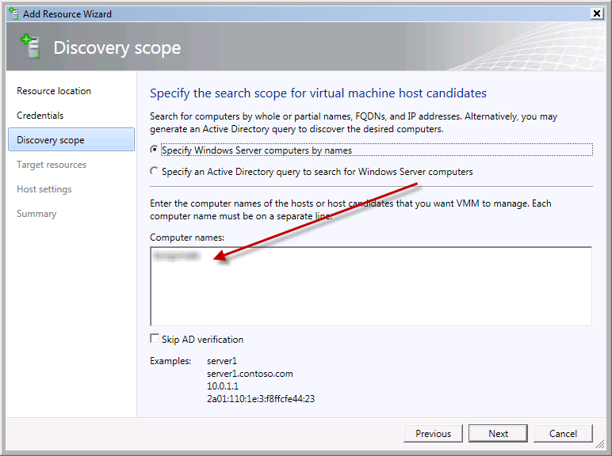
- Choose Specify Windows Server computers by names
- In the Computer names box, enter the name of the Hyper-V host you want to add
- Click Next

The installer will search for the servers in Active Directory and eventually display them on the Select the computers that you want to add as hosts page.
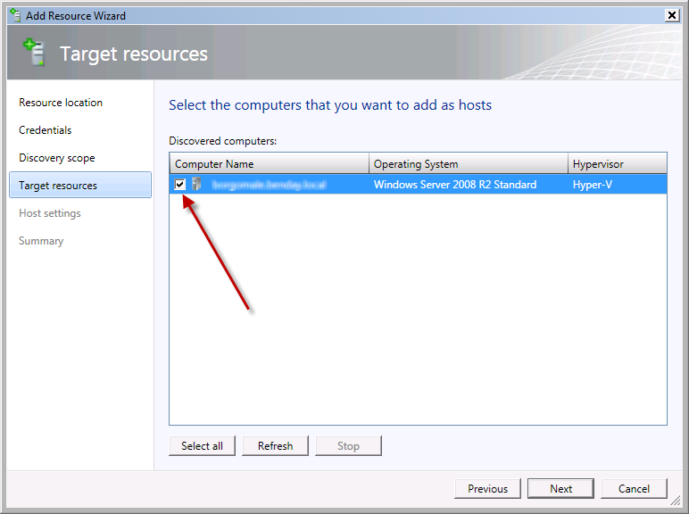
- Check the checkbox next to each server you want to add
- Click Next

The wizard should now be displaying the Specify a host group and virtual machine placement path settings for hosts page.
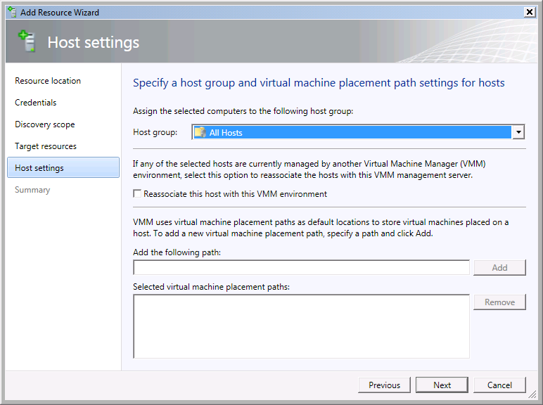
- Click Next

You should now see the Confirm the settings page with a summary of your selections.
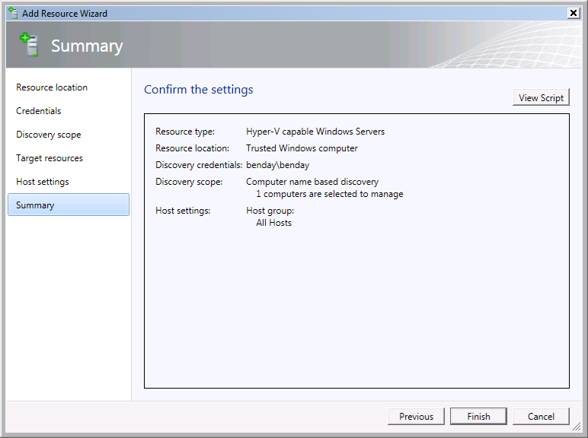
- Click Next

You should see a new Jobs window pop up and you should see the Add virtual machine host job running.
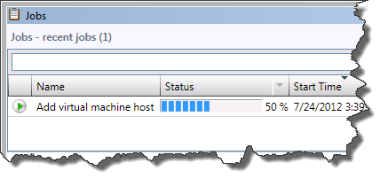
The job should complete without any errors. (Note: there may be “info” warnings.)
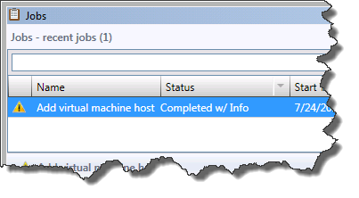
- Close the Jobs window

After you close the jobs window, you should see the SCVMM Console again. In the left column, you should see the new host you just added and, if you click on the host, the list of virtual machines on that host should be visible.
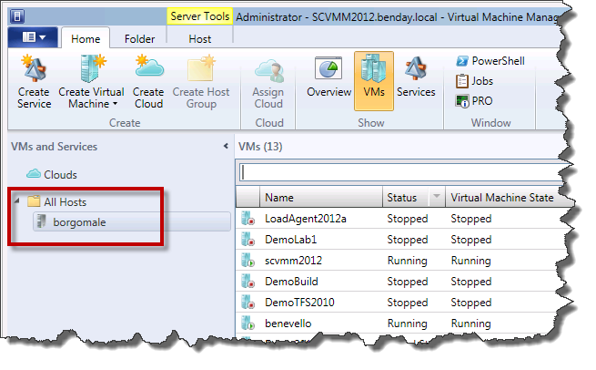

Configure System Center Virtual Machine Manager 2012 (SCVMM2012) for Team Foundation Server 2012 (TFS2012)
In order to interact with SCVMM, the service account for Team Foundation Server (TFS) needs administrator permissions.
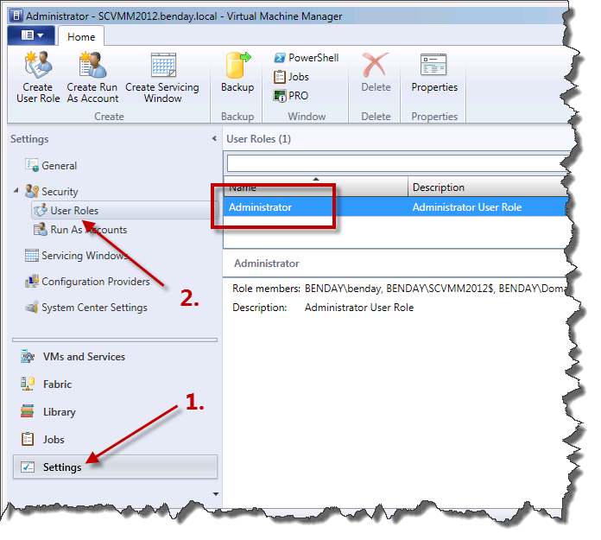
- Click the Settings button
- Expand the Security node and click User Roles
- Double-click the Administrator role

You should now see the Administrator Properties dialog.
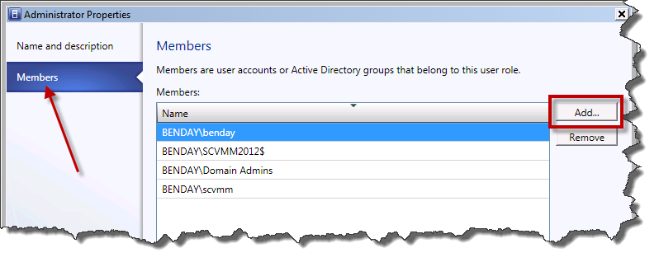
- Click the Members button in the left column
- Click the Add… button

On the Select Users, Computers, or Groups dialog, enter the TFS service account user name.
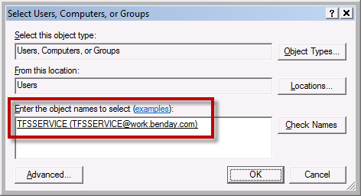
- In the Enter the object names to select box, type the username for the TFS service account (example: benday\TFSService)
- Click OK to exit the dialog

You should now be back on the Administrator Properties dialog.
- On the Administrator Properties dialog, click OK
- Close the SCVMM administrator console
- Run Windows Update and install any available updates

Configure Team Foundation Server to Use Lab Management
At the moment, our TFS machine doesn’t know anything about the System Center configuration that we’ll use for Lab Management. To start, we’ll need to install System Center Virtual Machine Manager on our TFS machine.
- Log on to the Team Foundation Server machine as a user with Administrator permissions
- Insert the SCVMM 2012 disk or mount the ISO
- Click Run setup.exe

You should see the Microsoft System Center 2012 Virtual Machine Manager installer welcome page.
- Click Install

The setup wizard will prompt you to select features to install.
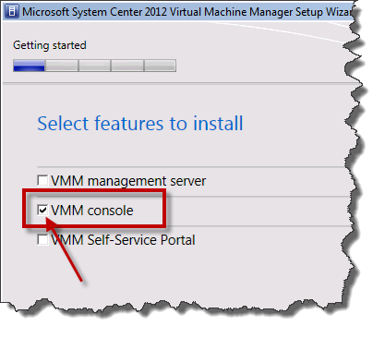
- Check VMM console
- Click Next

You should now see the Please read this notice screen.
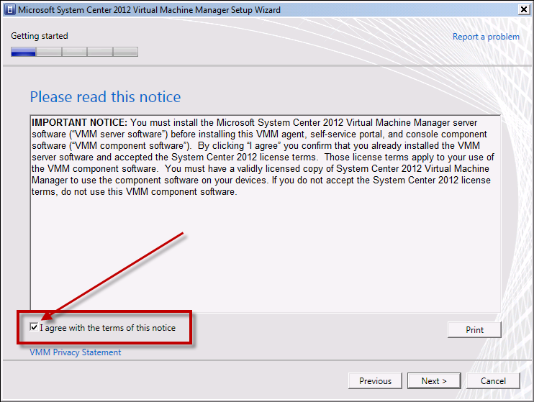
- Check the I agree with the terms of this notice checkbox
- Click Next
You should now see the Customer Experience Improvement Program page.
- Click Next
You should now see the Installation location page.
- Click Next

You should now see the Port configuration page. If you used all the default values when you installed the SCVMM server, you don’t have to make any changes on this page.
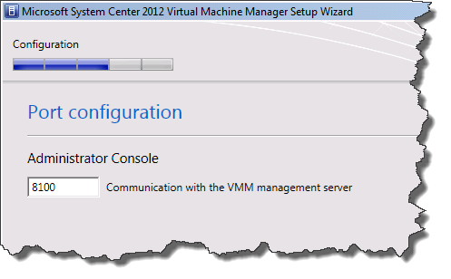
- Click Next

You should now see the Installation summary page.
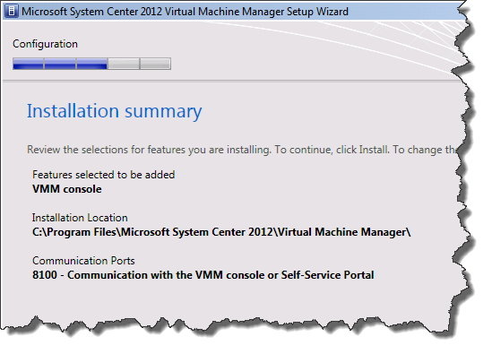
- Click Install

You should now be on the Setup completed successfully page and you should see that the VMM console feature installed successfully.
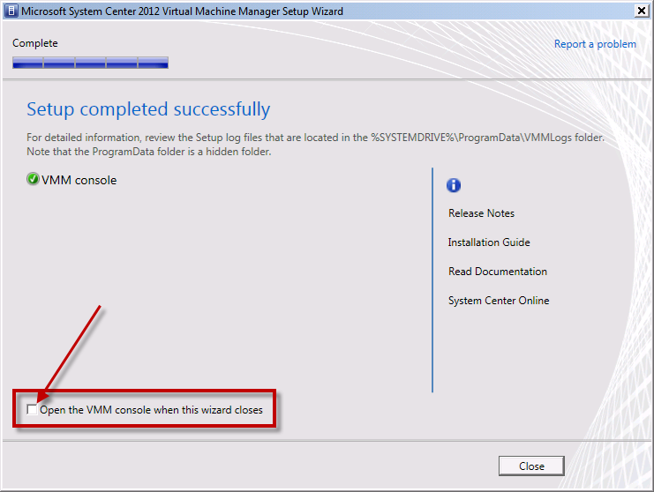
- Uncheck Open the VMM console when this wizard closes
- Click Close

You should be back at the main page of the SCVMM installer.
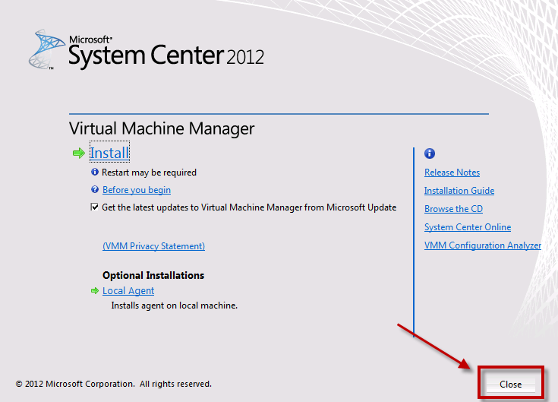
- Click Close

Enable the Team Foundation Server 2012 Lab Management Feature
You’ll now need to run the Team Foundation Server Administration Console in order to enable the Lab Management features.
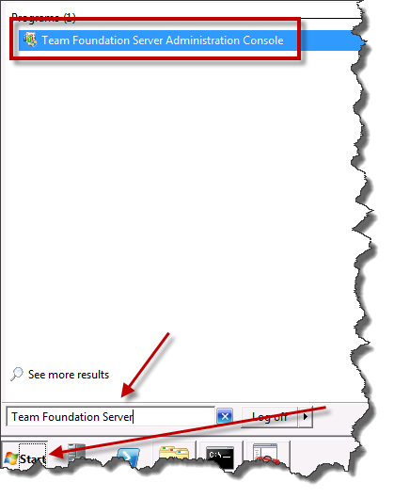
- Click the Windows Start button
- In the search box, type Team Foundation Server
- From the search results, choose Team Foundation Server Administration Console

When the administration console loads, you’ll need to navigate to the Lab Management section.
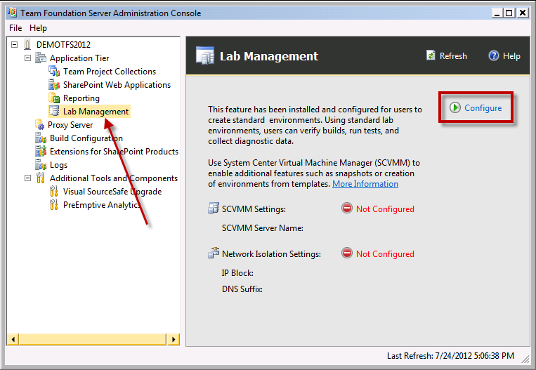
- From the left column, click Lab Management
- In the right panel, click Configure

You should now see the Lab Management Settings dialog. This dialog connects your TFS installation to SCVMM.
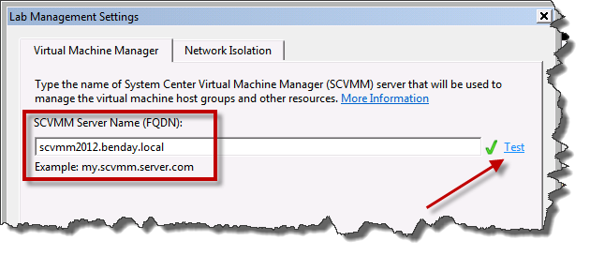
- In the SCVMM Server Name (FQDN) box, type the fully-qualified name of your SCVMM server.
- Click the Test link
- After the Test link has run, verify that the checkmark is visible
- Click OK

You should now be back on the Lab Management configuration page and you should see a message saying “none of the existing team project collections is configured to use SCVMM.”
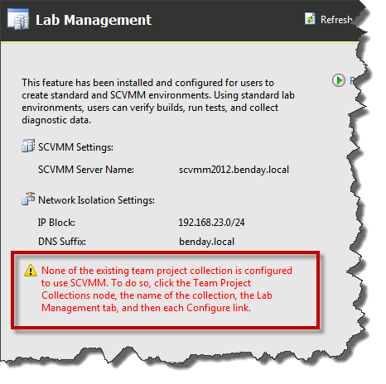

To configure your Team Project Collection(s) for Lab Management, start by going to the Team Project Collections node.
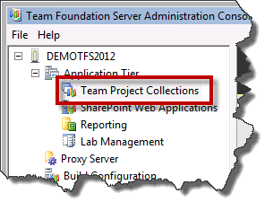
- In the left side panel, click Team Project Collections
This will take you to the Team Project Collections page.
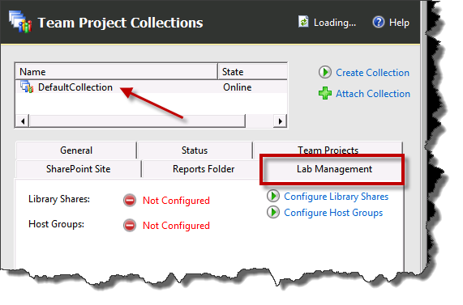
- Click the Name of the Team Project Collection that you want to configure
- Click the Lab Management tab
You should see that the Library Shares and Host Groups are listed as Not Configured.
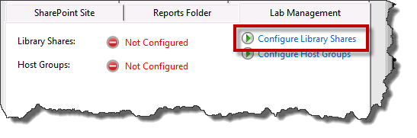
- Click the Configure Library Shares link
You should now see a dialog named Lab Management Settings.
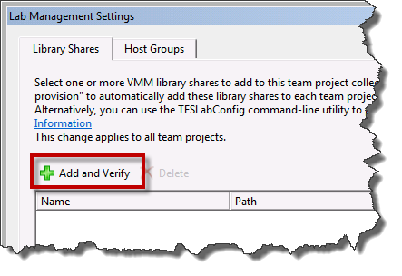
- Click the Library Shares tab
- Click the Add and Verify button

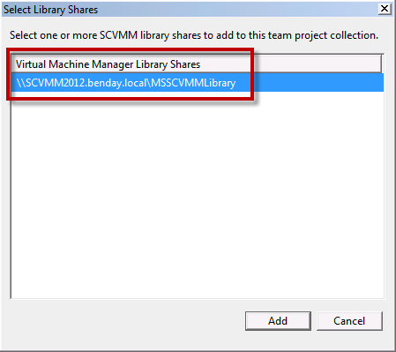
- Select one or more library shares from the Virtual Machine Manager Library Shares list.
- Click Add

You should now be back on the Library Shares tab.
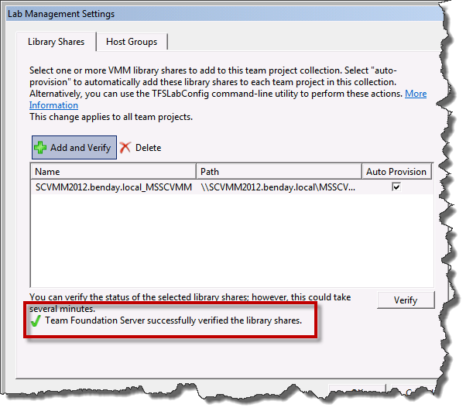
- Verify that you see the message Team Foundation Server successfully verified the library shares.

Now that you’ve configured the Library Shares, you can configure the Host Groups.
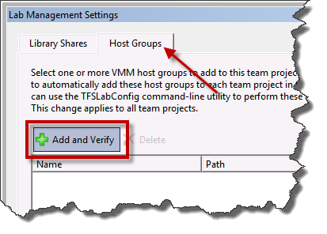
- Click on the Host Groups tab
- Click Add and Verify
You should now see the Select Host Groups dialog.
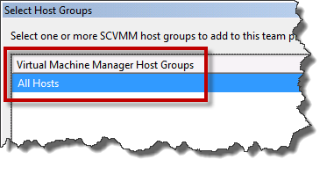
- Choose the appropriate Host Group from the list. (Example: All Hosts)
- Click Add

You should now be back on the Lab Management Settings dialog and you should see the host groups you just added in the list.
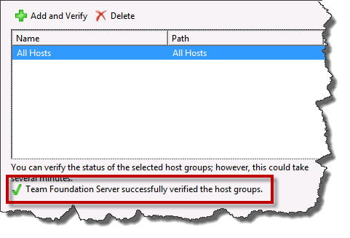
- Verify that the Team Foundation Server successfully verified the host groups dialog is displayed
- Click OK

You should now see the Library Shares and Host Groups section of the administrator showing that there are now configured values.
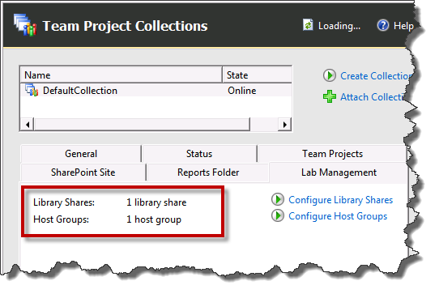
You’ve completed configuring Lab Management and SCVMM for your server.

